Industrial Engg. & Management
(Th- 01)

Sixth Semester
Mechanical Engg.

NAME OF THE SUBJECT-INDUSTRIAL ENGINEERING AND MANAGEMENT (IEM)

SL NO | CHAPTER NAME | MARKS
1 | PLANT ENGINEERING | 20
2 | OPERATION RESEARCH | 20
3 | INVENTORY CONTROL | 25
4 | INSPECTION AND QUALITY CONTROL | 20
5 | PRODUCTION PLANNING AND CONTROL | 15
 | TOTAL | 100

INTRODUCTION TO INDUSTRIAL ENGINEERING

Industrial engineering is an engineering profession that is concern with the optimization of complex processes ,system or organization by developing, improving and implementing integrated systems of people ,money ,knowledge, information and equipment.

The focus of industrial engineering is how to improve processes or design things that are more efficient and waste less money, time, raw material, man power and energy while following safety standards and regulation. Industrial Engineers may use knowledge of math, physics but also social sciences to analyze, design, predict and evaluate the results and road blocks of processes and devices.

WINGS OF INDUSTRIAL ENGINEERING:-

- Manufacturing
- Finance, banking and service industry
- Defence and aero space
- Information and technology
- Health care
- Supply chain
- Education and research
- Management
- Technical sales and marketing
- Energy
- Public service

CHAPTER 01 PLANT ENGINEERING

A plant is a place where man, material, money, equipment, machinery etc are brought together for manufacturing product.

SELECTION OF SITE OF INDUSTRY:

Selection of site for an industrial plant is governed by many considerations, both the economic analysis of the costs as well as judgment as to the modifying effects of other factors. The various factors areas follows-

    - Nearness to raw material: It will cost less if the plant site is located near the raw material source. The plant must be located in such a place that the raw materials are easily available.
    - Transport facilities: plant site must be located in such a place that ,where transport facilities like roads, rails ,water or air must be easily available.
    - Nearness to market: plant site must be near to the market for selling as well as exchanging its products.
    - Availability of labour: plant site must be located in such a place where labours with stable force of adequate size and reasonable rates are available.
    - Availability of fuel and power: plant site must be located in such a place where fuel and power both available easily because fuel and power are two main nutrients for a plant.
    - Availability of water: since water in adequate quantity is essential for every plant so the plant must be located in such a place where water availability is not so hard.
    - Climate condition: the plant site must be located in such a place where climate condition is not harse or adequate for plant.
    - Land: the plant site must be located in such a place where vast land must be available easily at low price.
    - Community Attitude: plant must be located in such a place where community i.e local MLA ,ward member, general public)must be friendly.

PLANT LAYOUT

It is defined as a technique of locating machines , processes and plant services with in the factory so as to achieve the greatest possible output of high quality at the lowest possible total cost of manufacturing.

OBJECTIVES and PRINCIPLES OF PLANT LAYOUT Objectives
- Proper and efficient utilization of available floor space.
- Transportation of work from one point to another.
- Proper utilization of production capacity.
- Reduce material handling cost.
- Utilize labour efficiently.
- Reduce accidents.
- Increase employee’s moral.
- Increase profit and reduce loss.

Principles

While designing the plant layout, the following principles must be kept in view.

- Material and labours should be moved over minimum distances.
- All available cubic space should be effectively utilized –both horizontally and vertically.
- Layout should be flexible enough to adaptable to changes required by expansion.
- Interdependent operations and processes should be located in close proximity to each other, to minimize product travel.
- All the plant facilities and services should be fully integrated into a single operating unit.
,to minimize cost of production.
- There should be in-build provision in the design of layout, to provide for comfort and safety of workers.
- A good layout should facilitate effective supervision over workers.
- A good layout should boost up employee moral, by providing them with maximum work satisfaction.

PROCESS LAYOUT, PRODUCT LAYOUT, COMBINATION LAYOUT Process Layout (Or Functional Layout)
In this type of layout, all machines performing similar type of operations are grouped at one location that is all lathes, milling machines etc are grouped in the shop and they will be clustered in like groups.

Lathe | Milling machine |  | Assembly
Welding | Grinding | Inspection | Shiping and receiving | painting

Advantages:-

- Greater flexibility
- Lower investment
- Higher utilization of production
- Breakdown of one machine does not result in complete stopping of work. Disadvantages:
- Back tracking and long movement.
- Production planning and control is difficult.
- More space requirement.

Product Layout (Or Line Layout)

In this type of layout ,all the machines are arranged in the sequences ,as required to produce a specific product .It is called line layout because machines are arranged in a straight line. The raw materials are fed at one end and taken out as finished product to the other end.
Turning operation -> milling operation -> drilling operation -> assembly -> inspection -> package dispatch
Advantages:-

- Reduce material handling cost.
- Eliminates bottlenecks and idle capacity.
- Short manufacturing cycles.
- Small amount of work in process inventory.
- Simplified production planning. Disadvantages:-
- Lack of flexibility of operations.
- Large capital investments.
- Breakdown of one machine in the sequence may result in stoppage in production.

Combination Layout

In actual practice, plants are rarely worked in product or process layout. Generally plant works on a combination of these two layouts take the advantages of both layouts.
Example-1 :refrigerator manufacturing uses a combination layout.

Example 2-Process layout is used to produce various operations like stamping, welding, heat treatment being carried out indifferent work centers as per requirement. The final assembly of the product is done in a product layout.

TECHNIQUES TO IMPROVE LAYOUT

Different techniques are used for a good plant layout are:-

- Integration:- it means the integration of production centers facilities like workers
,machinery, raw materials etc in a logical and balanced manner.
- Minimum movement and material handling:- the number of movements of workers and material should be minimized.
- Smooth and continuous flow:- bottle necks ,congestion points and backtracking should be removed.
- Cubic space utilization:- besides using the floor space of a room, if the ceiling height is also utilized, more material can be accommodated in the same room.
- Safe and improved environments:- working place safe, well ventilated and free from dust and noise increases the operating efficiency of the workers and thus better employer –employee relations.
- Flexibility:- in automotive and other industries where model of products change after some time, it is better to permit all possible flexibility in the layout.

PRINCIPLES OF MATERIAL HANDLING EQUIPMENTS:

Following are the principles of material handling.

- Space utilization principle: make optimum use of cubic space.
- Unit load principle:- increase quantity, size weight of load handled.
- Gravity principle:-utilize gravity to move a material whenever practicable.
- Material flow principle:-plan an operation sequence and equipment arrangement to optimize material flow.
- Mechanization principle:-use mechanical and automated material handling equipment.
- Safety principle:-provide for safe handling methods and equipments.

PLANT MAINTENANCE:-

It is defined as a set of activities that are necessary to keep machinery ,parts and types of equipments in good operating conditions to avoid production stoppage and loss.

IMPORTANCE OF PLANT MAINTENANCE:-

      - It helps in identify the cause of failure, example whether the failure is due to design defect or wear out failure.
      - It also helps in deciding the type of maintenance and maintenance decision like replace and repair.
      - It provides the necessary information regarding the life and reliability of the equipment.
      - With the help of this tool spare parts management got initiated.

BREAK DOWN MAINTENANCE:-

      - Breakdown Maintenance implies that repairs are made after the equipment is failed and failed and cannot perform its normal function any more.
      - It is an emergency based policy in which the plant or equipment is operated until it fails and then it is brought back into running condition by repair.
      - The maintenance staff locates any mechanical, electrical or any other faulty to correct immediately.

PREVENTIVE MAINTENANCE:-

      - Preventive maintenance is a type of maintenance that is regularly performed on a piece of equipment to loosen the likelihood of it failing.
      - It is performed while the equipment is still working so that it does not breakdown unexpectedly.
      - Preventive maintenance are of two types:-
        - Time based preventive maintenance:- a typical example of a time-based preventive maintenance is a regular inspection on a critical piece of equipment that would severely impact production in the event of a break down.
        - Usage- based preventive maintenance:- usage based triggers fires after a certain amount of kilometers, hours or production cycles. An example of this trigger is a motor –vehicle which might be scheduled for service every 10,000 km.

SCHEDULED MAINTENANCE:-

      - Scheduled maintenance is a stich –in –time procedure aimed at avoiding breakdown.
      - Breakdowns can be dangerous to life and as far as possible should be minimized.
      - Scheduled maintenance practice incorporates inspection, lubrication, repair and overhaul of certain equipments which if neglected can result in break down.

POSSIBLE SHORT QUESTIONS WITH ANSWERS:

- Define a plant?

Ans :- A plant is a place where man, material, money, equipment, machinery etc are brought together for manufacturing product.
- What is plant maintenance?

Ans:- It is defined as a set of activities that are necessary to keep machinery ,parts and types of equipments in good operating conditions to avoid production stoppage and loss.
- Define plant layout?

Ans:- It is defined as a technique of locating machines , processes and plant services with in the factory so as to achieve the greatest possible output of high quality at the lowest possible total cost of manufacturing.

POSSIBLE LONG QUESTIONS WITH HINTS:

- Briefly explain the features governing while selecting the site for an industry? Ans: refer article no-1.1

- Write the objectives and principles of a good plant layout? Ans:- refer article no-1.3

- What is plant maintenance? Explain different types of plant maintenances? Ans:-refer article no- 1.7

……………..0……………..

CHAPTER 2 OPERATION RESEARCH

INTRODUCTION:

Historically, the term operation research originated during second world war when
U.S.A and Great Britain ‘s Armed Forces sought the assistance of scientists to solve complex and very difficult strategically and tactical problems of war fare, like making machine mines harmless or increasing the efficiency of antisubmarine aerial warfare etc.

INTRODUCTION TO OPERATION RESEARCH:-

Operation research employs mathematical logic to complex problems requiring managerial decisions. It is defined as, “ the organised application of modern science,
mathematics and computer techniques to complex military, government ,business problems arising in the management of large system of men, materials, money and machines.”
Applications:-

    - Inventory problems
    - Material handling
    - Dealing with waiting times
    - Dividing adverting budget.
    - Marketing etc
    - Traffic control.

: DEFINE LINEAR PROGRAMMING PROBLEM (LPP):

It is a mathematical model or techniques for efficient and effective utilization of limited resources to achieve organization objectives (maximize profits or minimize cost)

:- SOLUTION OF LPP BY GRAPHICAL METHOD:-

Steps for solution of LPP by graphical methods are as follows: Step -1: formulate the LPP
Step-2:construct a graph and plot the constraint lines. Step-3: determine the valid side of each constraint lines.

Step-4: identify the feasible solution region. Step-5: find the optimum points.
Step -6: calculate the co ordinates of optimum points.

Step -7: evaluate the objective function at optimum points to get the required maximum/minimum value of the objective function.
Problem-1: solve the following LPP by using graphical method. Maximize Z =12X1+16X2
Subjected to, 10X1 + 20X2 ≤ 120

8X1 + 8X2 ≤ 80

X1 and X2 ≥0

Solution:- Maximize Z =12X1+16X2 (objective function)

10X1 + 20X2 =120......................................... (1) } two constraints
8X1 + 8X2 = 80 (2)

When X1=0 in equation 1 10(0) + 20X2 =120
- 0+20X2 =120
- 20X2 = 120
- X2 = 120/20=6

When X2= 0, in equation 1,we have 10X1 + 20 (0) =120
- 10X1 +0 =120
X1 | 0 | 12
X2 | 6 | 0

- 10X1 = 120
- X1 = 120/10 =12

When X1 =0, in equation 2
- 8(0) + 8X2 =80

- 0+ 8X2=80
X1 | 0 | 10
X2 | 10 | 0

- 8X2 =80
- X2 =80/8
- X2 =10
When X2=0 in equation 2, we have, 8X1 +8(0) =80
- 8X1 = 80
- X1= 80/8 =10

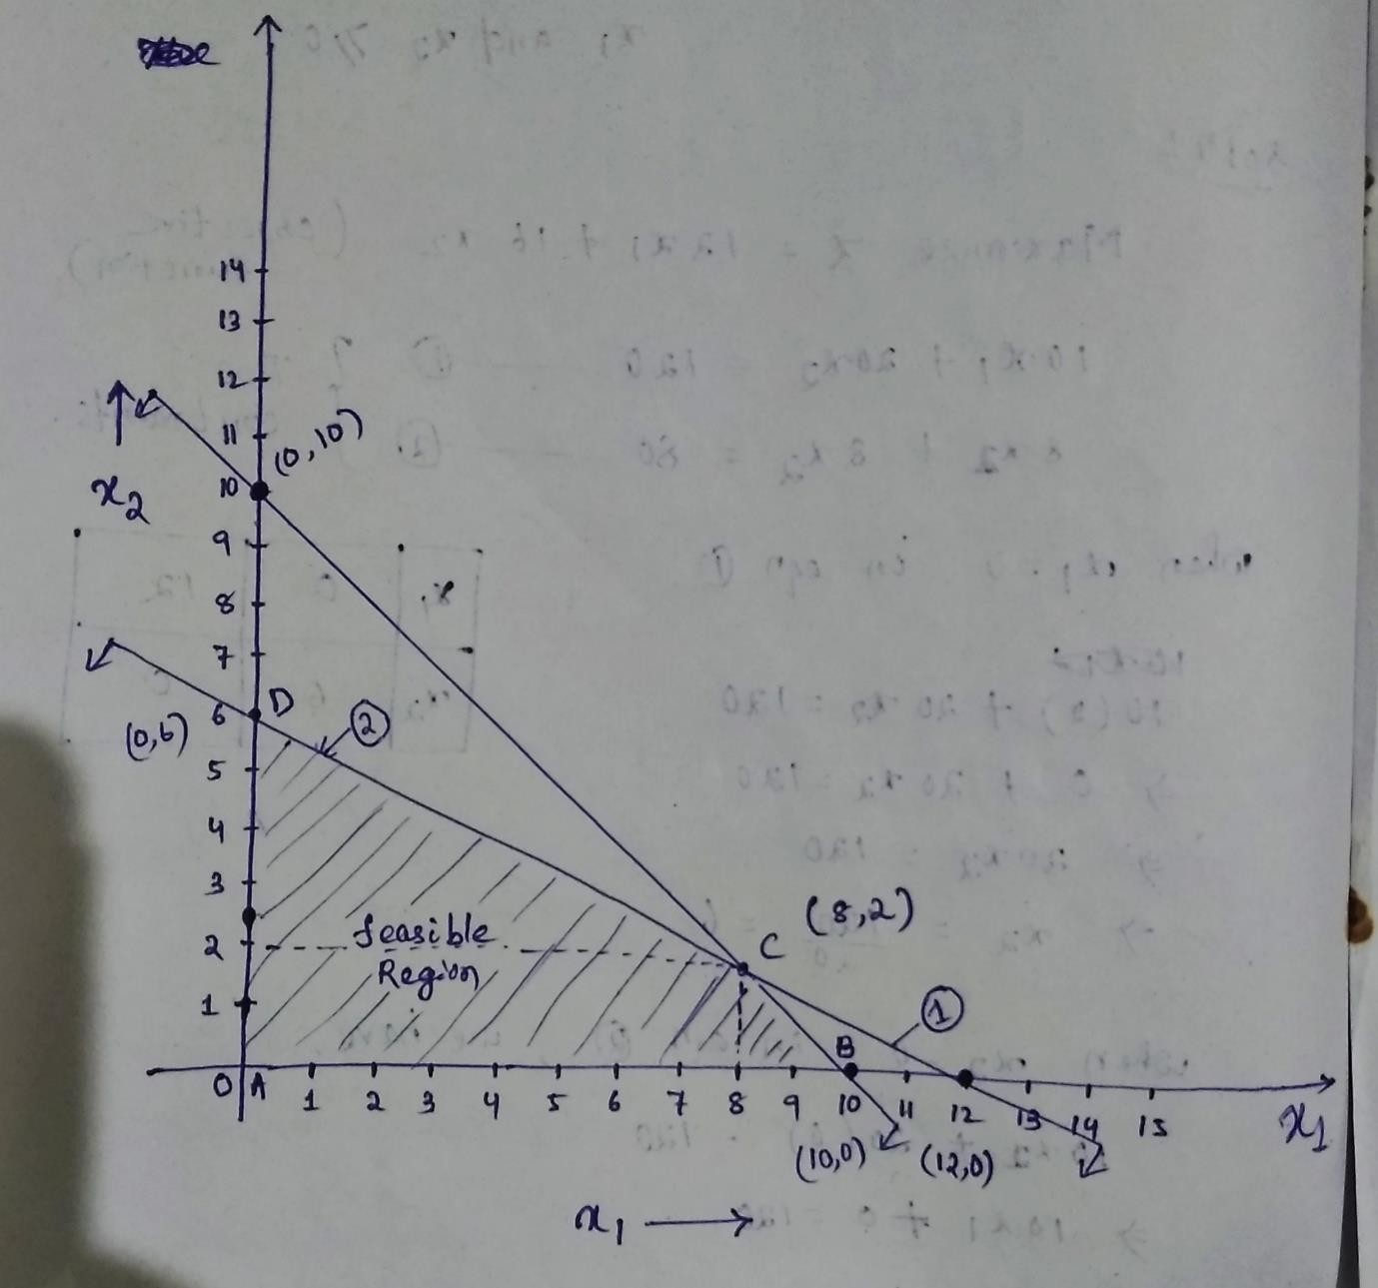

Now to find the optimum solution let us substitute the four corner points in the objective function.
Maximize Z =12X1+16X2

A(0,0) Z(A) =12(0) + (16(0) =0
B(10,0) Z(B) =12(10) + 16(0) =120
C(8,2) Z(C) =12(8) + 16(2) =128
D(0,6) Z(D) =12(0) + 16(6) =96

Since the type of objective function is maximization, the solution corresponding to maximum Z value will be selected as the optimum solution.
So optimum solution (C) X1=8 and X2 = 2
Z(optimum) = 128

Problem-2:solve the following LPP by using graphical method. Minimize Z =4X1+6X2

Subjected to, X1 + X2 ≥ 8

6X1 + X2 ≥12

X1 and X2 ≥0

Solution:- Minimize Z =4X1+6X2 (objective function)
X1 + X2 = 8.........................................(1) }two constraints
6X1 + X2 = 12 (2)

When X1=0 in equation 1 (0) + X2 =8
- X2 = 8
When X2= 0, in equation 1,we have
X1 | 0 | 8
X2 | 8 | 0

X1 + (0) =8
- X1 =8

When X1 =0, in equation 2
- 6(0) + X2 =12
- 0+ X2=12
- X2 =12

When X2=0 in equation 2, we have,
X1 | 0 | 2
X2 | 12 | 0

6X1 +(0) =12
- 6X1 = 12
- X1= 12/6 =2

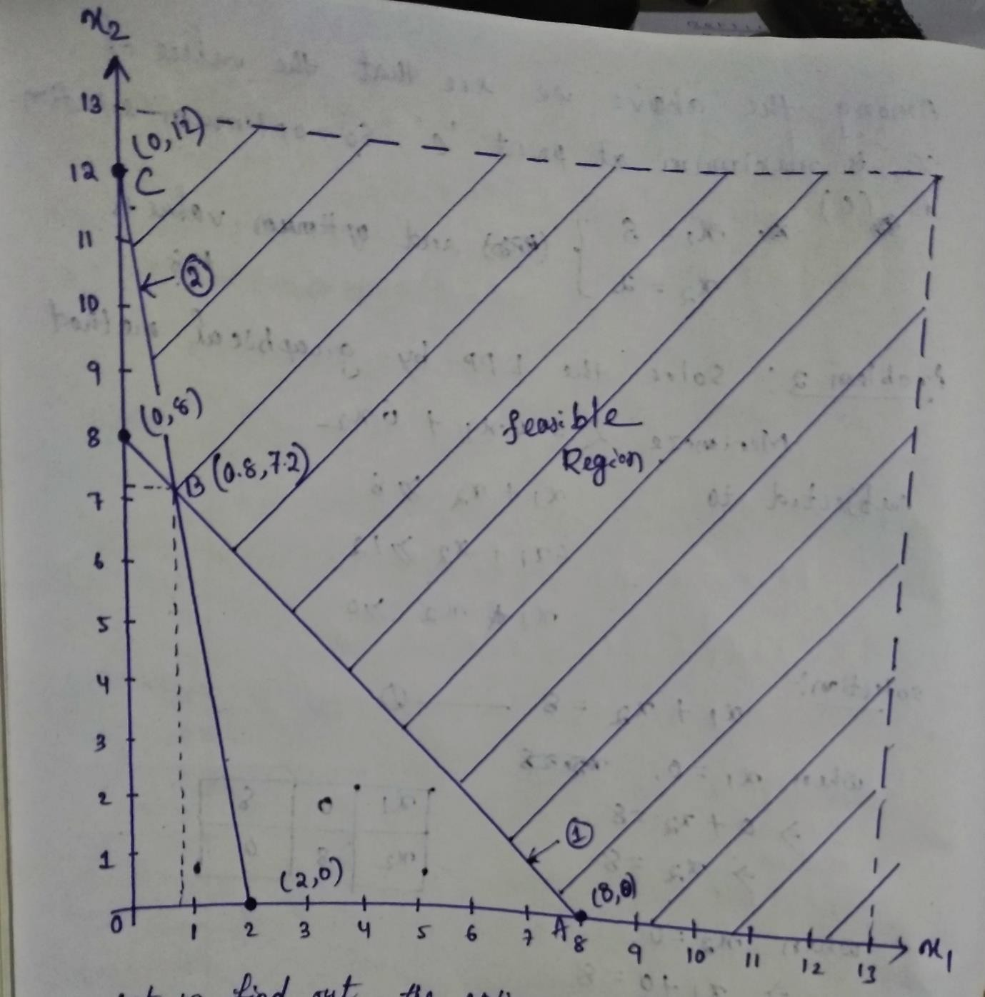

Now to find the optimum solution let us substitute the four corner points in the objective function.
Minimize Z =4X1+6X2
A(8,0) Z(A) =4(8) + 6(0) =32
B(0.8,7.2) Z(B) =4(0.8) + 6(7.2) =3.2+43.2=46.4
C(0,12) Z(C) =4(0) + 6(12) =0+72=72

Since the type of objective function is minimization, the solution corresponding to minimum Z value will be selected as the optimum solution.
So optimum solution (C) X1=8 and X2 = 0
Z(optimum) = 32

Problem-3:solve the following LPP by using graphical method. Maximize Z =100X1+60X2

Subjected to, 5X1 +10X2 ≤ 50

8X1 +2X2 ≥16

3X1 -2X2 ≥6

X1 and X2 ≥0

Solution:- Maximize Z =100X1+60X2 (objective function)
5X1 +10X2 = 50.........................................(1) }two constraints
8X1 + 2X2 = 16 (2)

3X1 - 2X2 = 6 (3)

When X1=0 in equation 1 5(0) + 10X2 =50
- 10X2 = 50
- X2 =50/10=5
When X2= 0, in equation 1,we have 5X1 + 10(0) =50
- 5X1 =50
X1 | 0 | 8
X2 | 8 | 0

- X1 = 50/5=10
When X1 =0, in equation 2
- 8(0) + 2X2 =16
- 0+2 X2=16
- X2 =16/2=8

When X2=0 in equation 2, we have,
X1 | 0 | 2
X2 | 12 | 0

8X1 +2(0) =16
- 8X1 = 16
- X1= 16/8 =2
When X1 =0, in equation 3
- 3(0) - 2X2 =6
- -2 X2=6
- X2 =6/-2=-3
When X2=0 in equation 3, we have, 3X1 -2(0) =6
- 3X1 = 6
- X1= 6/3 =2

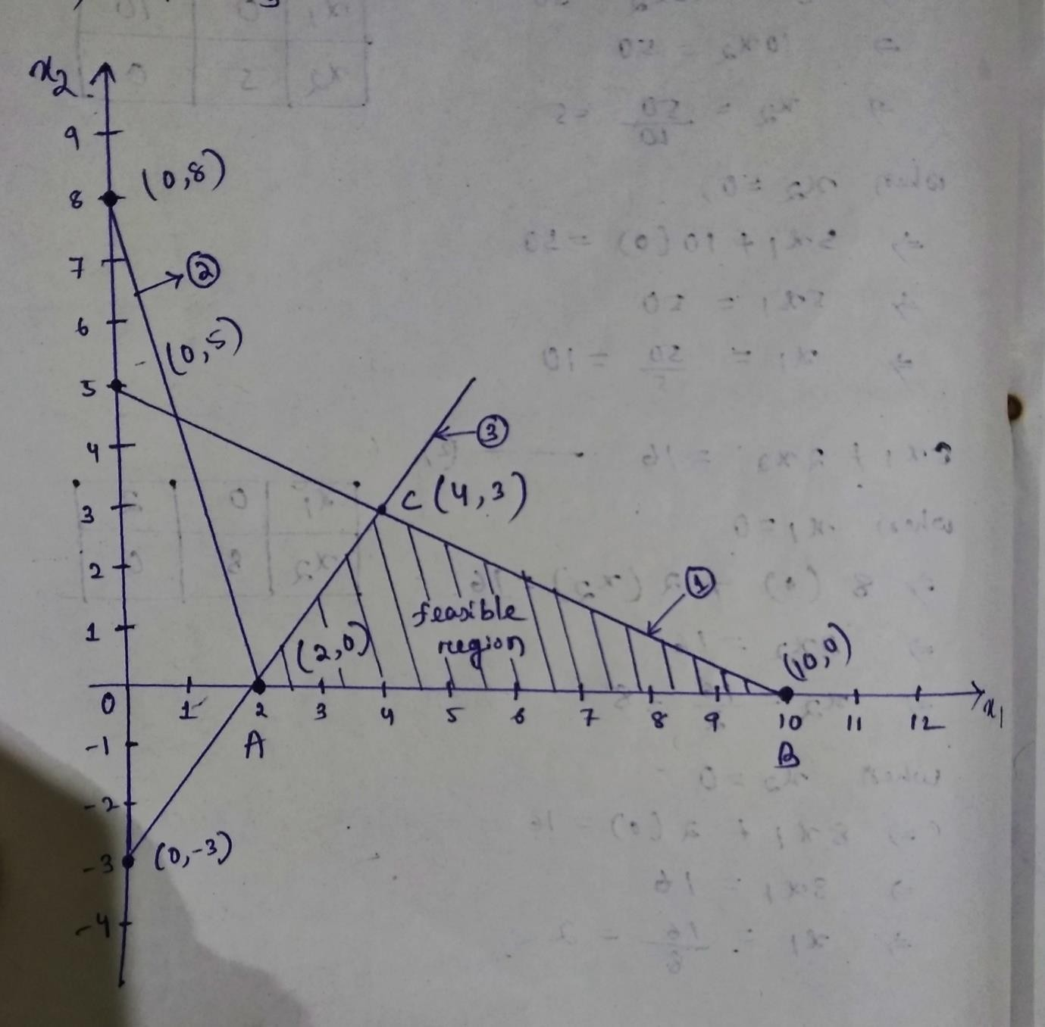

Now to find the optimum solution let us substitute the four corner points in the objective function.
Maximize Z =100X1+60X2
A(2,0) Z(A) =100(2) + 60(0) =200
B(10,0) Z(B) =100(10) + 60(0) =1000
C(4,3) Z(C) =100(4) + 60(3) =400+180=580

Since the type of objective function is maximization, the solution corresponding to maximum Z value will be selected as the optimum solution.
So optimum solution (B) X1=10 and X2 = 0
Z(optimum) = 1000

EVALUATION OF PROJECT COMPLETION TIME BY CRITICAL PATH METHOD AND PERT:-

PROJECT MANAGEMENT:-
    - A project consists of interrelated activities which are to be executed in a certain order before the entire task is completed.
    - The activities are inter-related in a logical sequences which is known as precedence relationship.
    - Project is represented in the form of network for the purpose of analytical treatment to get solutions for scheduling and controlling its activities.
Techniques:-

- CPM:-critical path method
- PERT:-project Evaluation and review technique. Phases of project Management:-
- Planning-
- During the project into distinct activities.
- Estimating the requirement for each activity.
- Establishing precedence relationship among the activities.
- Construction of the arrow diagram(network)
- Scheduling-
- Determines the start and end time of each activity and every activity.
- Controlling-

Uses the arrow diagram and time chart for continuous monitoring and progress reporting

Evaluation Of Project Completion Time By Critical Path Method (CPM):
  - Critical path method (CPM) is a resource-utilization algorithm
for scheduling a set of project activities. The essential technique for using CPM is to construct a model of the project that includes the following:
  - A list of all tasks required to complete the project
  - The dependencies between the tasks
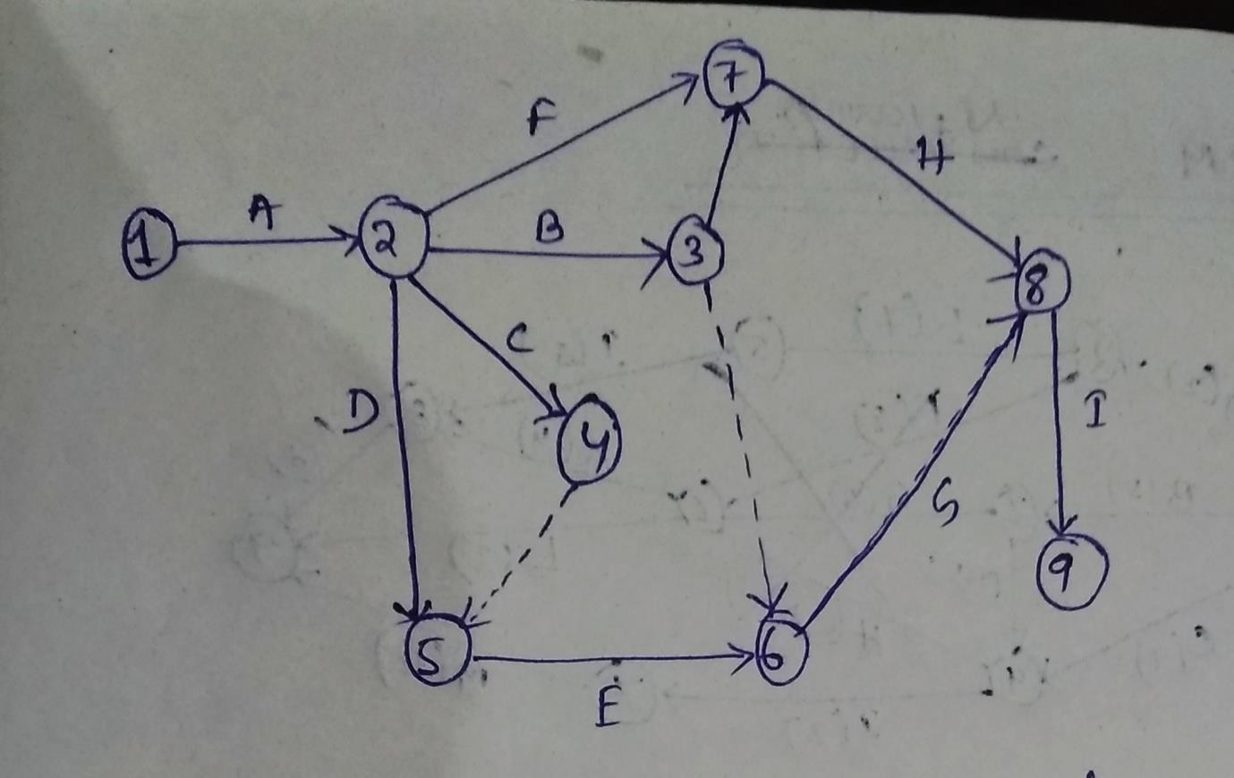
  - The estimate of time (duration) that each activity will take to complete. GUIDE LINES FOR NETWORK CONSTRUCTION:-
- The starting event and ending event of an activity base called tail event and head event, respectively.
- The network should have a unique starting node (tail event).
- The network should have a unique completion node (head event).
- No activity should be represented by more than one arc in the network.
- No two activities should have the same starting node and the same ending node.
- Dummy activity is an imaginary activity indicating precedence relationship only. Duration of dummy activities is zero.

Problem-4:-

Consider the details of a project as shown in the table.

ACTIVITY | IMMEDIATE PREDECESSOR(S) | DURATION(MONTHS)
A | - | 2
B | - | 5
C | - | 4
D | B | 5
E | A | 7
F | A | 3
G | B | 3
H | C,D | 6
I | C,D | 2
J | E | 5
K | F,G,H | 4
L | F,G,H | 3
M | I | 12
N | J,K | 8

- Construct the CPM network
- Determine the critical path and project completion time
- Compute total float and free floats for non-critical activities.

Solution:-

a)CPM NETWORK:-

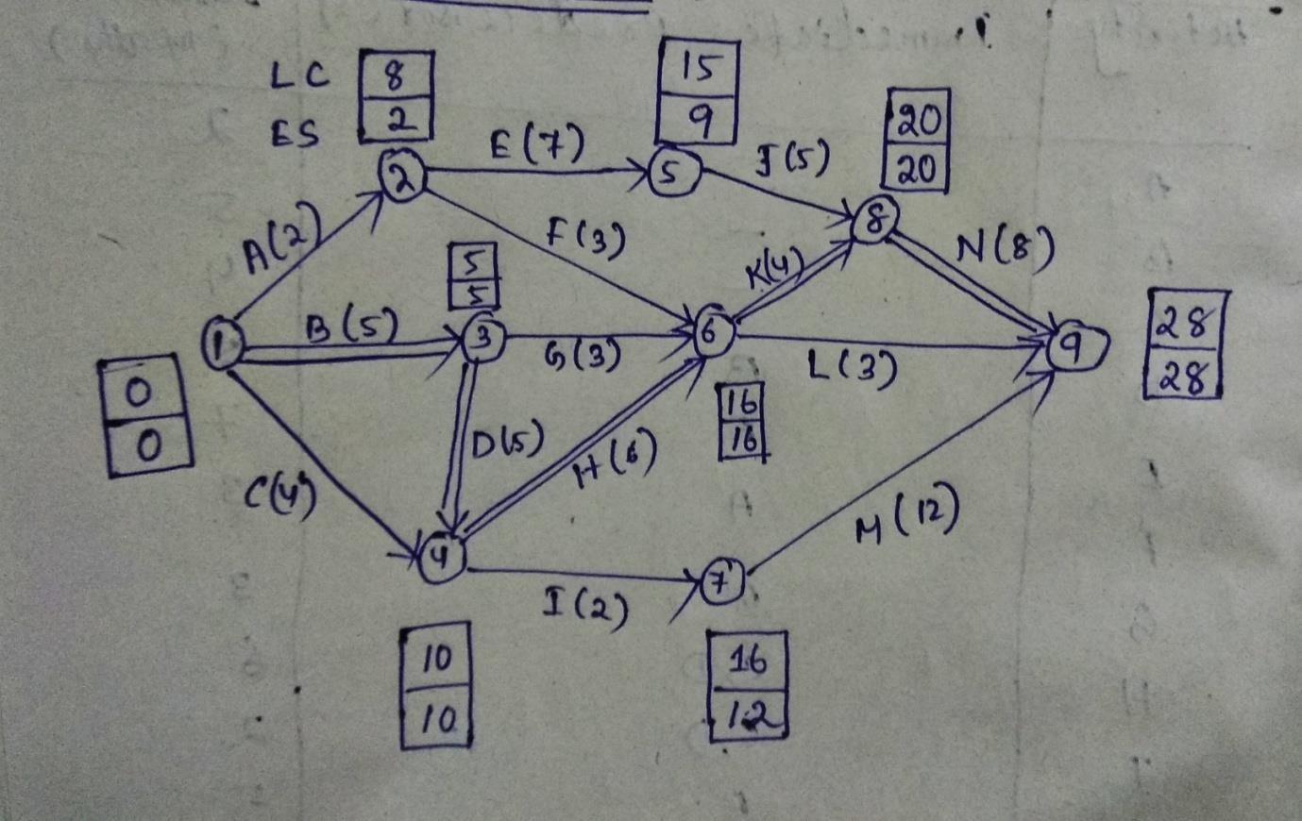

b) 1-3-4-6-8-9 = B-D-H-K-N = 5+5+6+4+8 = 28 is the critical path.

Hence the duration of critical path is 28 months and project duration is 28 months.

C) Summary of total floats and free floats:

Activity (i,j) | Duration (D_{ij}) | Total float( TF_{ij})  LC_{l} - ES_{i} - D_{ij} | FREE float( FF_{ij})  ES_{j} - ES_{i} - D_{ij}
A 1-2 | 2 | 8-0-2=6 | 0
B 1-3 | 5 | 5-0-5=0 | 0
C 1-4 | 4 | 6 | 6
D 3-4 | 5 | 0 | 0
E 2-5 | 7 | 6 | 0
F 2-6 | 3 | 11 | 11
G 3-6 | 3 | 8 | 8
H 4-6 | 6 | 0 | 0
I 4-7 | 2 | 4 | 0
J 5-8 | 5 | 6 | 6
K 6-8 | 4 | 0 | 0
L 6-9 | 3 | 9 | 9
M 7-9 | 12 | 4 | 4

N 8-9 | 8 | 0 | 0

Any activity will have zero total float and zero free float is called critical activity.

EXPLAIN DISTINCT FEATURES OF PERT WITH CPM

PERT | CPM
- A probabilistic model with uncertainty in activity duration. Expected time is calculated from t0,tm and to.  - An event oriented approach.  - PERT terminology uses words like network diagram, events and stack.  - The uses of dummy activity are required for representing the proper sequencing.  - PERT finds application in projects where resources (men, materials and money) are always available as and when required.  - It is used mostly in research and development projects. | - A deterministic model with well known activity time based upon past experience.  - An activity oriented system.  - CPM terminology employs works like arrow diagrams, nodes and floats.  - The uses of dummy activity are not necessary.  - CPM is employed to those projects where minimum overall costs are of primary importance.  - It is used in construction projects.

POSSIBLE SHORT QUESTIONS WITH ANSWER
- Define LPP ?

Ans:- It is a mathematical model or techniques for efficient and effective utilization of limited resources to achieve organization objectives (maximize profits or minimize cost)
- Define CRITICAL activity?

Ans:- In a network diagram ,critical activities are those, which if consumed more than their estimated time, the project will delayed.
It is marked either by a thick arrow or by double cross on the arrow distinguish it from a non critical activity.

- Define operation research?

Ans:- Operation research employs mathematical logic to complex problems requiring managerial decisions. It is defined as, “ the organised application of modern science, mathematics and computer techniques to complex military,
government ,business problems arising in the management of large system of men, materials, money and machines.”

POSSIBLE LONG QUESTIONS WITH HINTS

  - Use graphical method to find the optimal solution of following Maximize Z =12x +24y
Subjected to x+4y ≤ 20
3x+y ≤ 15 X,y ≥0
Hints :-Refer problem no-1

  - A small engineering projects consists of six activities namely P,Q,R,S,T,V with duration of 5,7,6,5,4 and 4 day respectively. Draw the network diagram and EST,LST, EFT,LFT and floats. Find the total project durations.
Hints :-Refer problem no-4

CHAPTER 3 INVENTORY CONTROL

INVENTORY:-
Inventory is a detailed list of those movable items which are necessary to manufacturer a product and to maintain the equipment and machinery in good working order.
The quantity and value of every item is also mentioned in the list.

INVENTORY CONTROL:-

Inventory control is concerned with achieving an optimum balance between two completing objectives. The objectives are:
- To minimize investment in inventory.
- To minimize the service level to the firm's customer and it’s own operating department.
Inventory control may also defined as the scientific method of finding out how much stock should be maintained in order to meet the production demands and able to provide right type of material at right time in the right quantity and at competitive prices.

INVENTORY CLASSIFICATION:-

Inventory may be classified as follows-

    - Raw inventories:- They include, raw material and semi finished products supplied by another firm and which are raw items for present industry.
    - In process inventories:-They are semi finished goods at various stages of manufacturing cycles.
    - Finished inventories:-They are the finished goods lying in stock rooms and waiting dispatch.

    - Indirect inventories:-They include lubricants and other items(like spare parts) needed for proper operation, repair and maintenance during manufacturing cycles.

OBJECTIVES OF INVENTORY CONTROL:
The main objectives of inventory management are operational and financial. The operational objectives mean that the materials and spares should be available in sufficient quantity so that work is not disrupted for want of inventory. The financial objective mean that investments in inventories should not remain idle and minimum working capital should be locked in it. The followings are the objectives of inventory management:
    - To ensure continuous supply of materials spares and finished goods so that production should not suffer at any time and the customer’s demand should also be met.
    - To avoid both overstocking and under-stocking of inventory.
    - To maintain investment in inventories at the optimum level as required by the operational and sales activities.
    - To keep materials cost under control so that they contribute in reducing cost of production and overall cost.
    - To eliminate duplication in ordering or replenishing stocks. This is possible with the help of centralizing purchases.
    - To minimize losses through deterioration, pilferage, wastages and damages.
    - To design proper organization for inventory management. Clear ut accountability should be fixed at various levels of the organization.
    - To ensure perpetual inventory control so that materials shown in stock ledgers should be actually lying in the stores.
    - To ensure right quality goods at reasonable prices. Suitable quality standards will ensure proper quality stocks. The price analysis, the cost analysis and value analysis will ensure payment of proper prices.

    - To facilitate furnishing of data for short term and long term planning and control of inventory.

  - FUNCTIONS OF INVENTORIES:-

    - To keep better customer satisfaction.
    - Maintain smooth and efficient production flow.
    - To avoid delays in deliveries.
    - To avoid problems during scarcity of materials in the market.
    - To take advantage of quality discounts.
    - To have an advantage amidst the market price fluctuation.
    - To allow possible increase in output.
    - To have better utilization of manpower and available machinery.
    - Avoid rejection of material.

  - THE BENEFITS OF INVENTORY CONTROL:-

    - Inventory control protects a company from fluctuations in demand of its products.
    - It enables a company to provide better services to its customers.
    - It keeps a smooth flow of raw-materials and aids in continuing production operations.
    - It checks and maintains the right stock and reduces the risk of loss.
    - It helps to minimize administrative workload, manpower requirement and even labour cost.
    - It tries to protect fluctuation in output.
    - It makes effective use of working capital by avoiding over-stocking.
    - It helps to maintain a check on loss of materials due to carelessness or pilferage (stealing).
    - It facilitates cost accounting activities. 10.It avoids duplication in ordering of stock.

  - COST ASSOCIATES WITH INVENTORY

Following are different costs associates with inventory in an organization

- Purchase Cost (P.C):-
  - It is also called nominal cost.
  - It is the cost incurred in buying from outside source.
  - This cost may very according to the quantity purchased.
  - Example-unit price Rs.20 for up to 100 units.,Rs.19.50 for more than 100 units.
  - P.C =No of units purchased × cost/unit.
- Ordering cost (O.C)/set up costs:-
  - It occurs when ever the stock replenish.
  - It is associated with processing and chasing the purchase order.
  - It is also called procurement cost.
  - It is independent to order size.
  - O.C = Number of orders × cost/order.
- Carrying cost/ Holding cost(H.C):
  - It is associated with storing an item in the inventory.
  - It is proportional to the amount of inventory and time taken to holding that inventory.
  - It is expressed in terms of rate per unit
  - H.C = Average inventory for a period × Holding cost /unit time.
- Stockout cost (S.C)
  - It is the cost incurred when customers are not being served.
  - This cost implies the shortages or absences of inventory.
  - It includes potential profit loss, good will loss, loss of production time, fast transportation cost, discount etc.
  - S.C = Average no. of units short × shortage cost / unit time
  - TERMINOLOGY OF INVENTORY CONTROL:-
- Terminology is a general word for the group of specialized words or meanings relating to a particular field, and also the study of such terms and their use.[1] This is also known as terminology science.

Some important terminologies of Inventory control are:-
- ABC analysis
- Economic order Quantity(EOQ)
- Purchase cost
- Ordering cost
- Holding cost
- Annual demand
- Shortage cost
- Inventory cycle stock etc.

  - EXPLAIN AND DERIVE ECONOMIC ORDER QUANTITY FOR BASIC MODEL:
Economic Order Quantity (EOQ):-
EOQ is one of the techniques of inventory control which minimize total Holding and ordering cost of the year.
The EOQ technique can solve the problems of material manager.

Derivation of EOQ for basic model:- Let Q is the economic lot size or EOQ C is the cost of one item.
I is the cost of carrying inventory
P is the procurement cost associated with one order U is the total quantity used per period say annually.
Number of purchase order to be furnished= total quantity/EOQ Total procurement cost = number of purchase orders × cost involved in one purchase
=U×P/Q (a)
Average annual inventory= Q/2
Inventory carrying cost=Average inventory× cost per items × cost of inventory in percent per period.
=Q/2 ×C× I (b)
Total cost,T= a +b=U×P/Q. + Q/2 ×C ×I
To minimize the total cost , differentiate T w.r.t, Q and put it equal to zero

𝑑𝑇

𝑑𝑄
𝑑
=
𝑑𝑄
𝑈 ∗ 𝑃 𝑄 ( +
𝑄 2
∗ 𝐶 ∗ 𝐼)

- 0 = -U.P.Q⁻²+𝐶.𝐼
2
- 𝑈𝑃 = 𝐶.𝐼
𝑄2 2
- Q2=2𝑈.𝑃
𝐶.𝐼
- Q =√2𝑈.𝑃
𝐶.𝐼
PROBLEM 1: given that
- Annual usage,U =60 units
- Procurement cost,p =Rs.15per order
- Cost per piece, C = Rs.100
- Cost carrying inventory I, a % including expenditure on obsolescence, taxes, insurance, deterioration etc =10%. Calculate E.O .Q.

  - Solution:- Q =√2𝑈.𝑃 =
𝐶.𝐼
2∗60∗15

10
100∗( )
√
100
= 13.41

Therefore, number of order per year = 60/13.41= 4.47 say 5 Hence Q or E.O.Q =60/5 =12 units (Ans)

PROBLEM 2: find the economic order quantity from the following data: Average annual demand =30,000 units
Inventory carrying cost =12% of the unit value per year. Cost of placing an order =Rs.70
Cost of unit =Rs 2

Solution:- :- Q =√2𝑈.𝑃 =
√
𝐶.𝐼
2∗30000∗70 = 4184
2∗( )
12
100

Therefore, number of order per year = 30000/4184= 7.17 say 7

DEFINE AND EXPLAIN ABC ANALYSIS:-

ABC analysis helps segregating the items from one another and tells how much valued the item is and controlling it to what extent is in the interest of the organization.
Procedural steps:-
    - Identify all items used in an industry.
    - List all the items as per their value.
    - Count the numbers of high valued ,medium valued and low valued items.
    - Find the percentage of high,medium and low valued items. High valued items normally contributes for 70% of the total inventory cost and medium and low valued items,20 and 10% respectively.
    - A graph can be plotted between percent of items(on X axis) and % of total inventory cost (on Y axis)
It can be seen that 70% of total inventory cost is against 10% of total items(called A items),20% against 20%of the items (B items) and 10% against a big bulk that is 70% of the items (called C items)
Thus ABC analysis furnishing the following information.
- A items are high valued items but are few in numbers.They need a careful and close inventory control.such items should be thought in advanced and purchase in small quantities well in time. Proper record and handling and storage facilities should be provided for them.
- B items are medium valued items and need moderate control.They are purchased on the basis of past requirements and a procurement order is placed as soon as the quantity touches reorder point. These items are less costly.
- C items are low valued items,but maximumnumbered items. These items do not need any control,rather controlling them is uneconomical. These are least important items like clips,all pins washer,rubber bands etc. They are generally procured just before they finished.

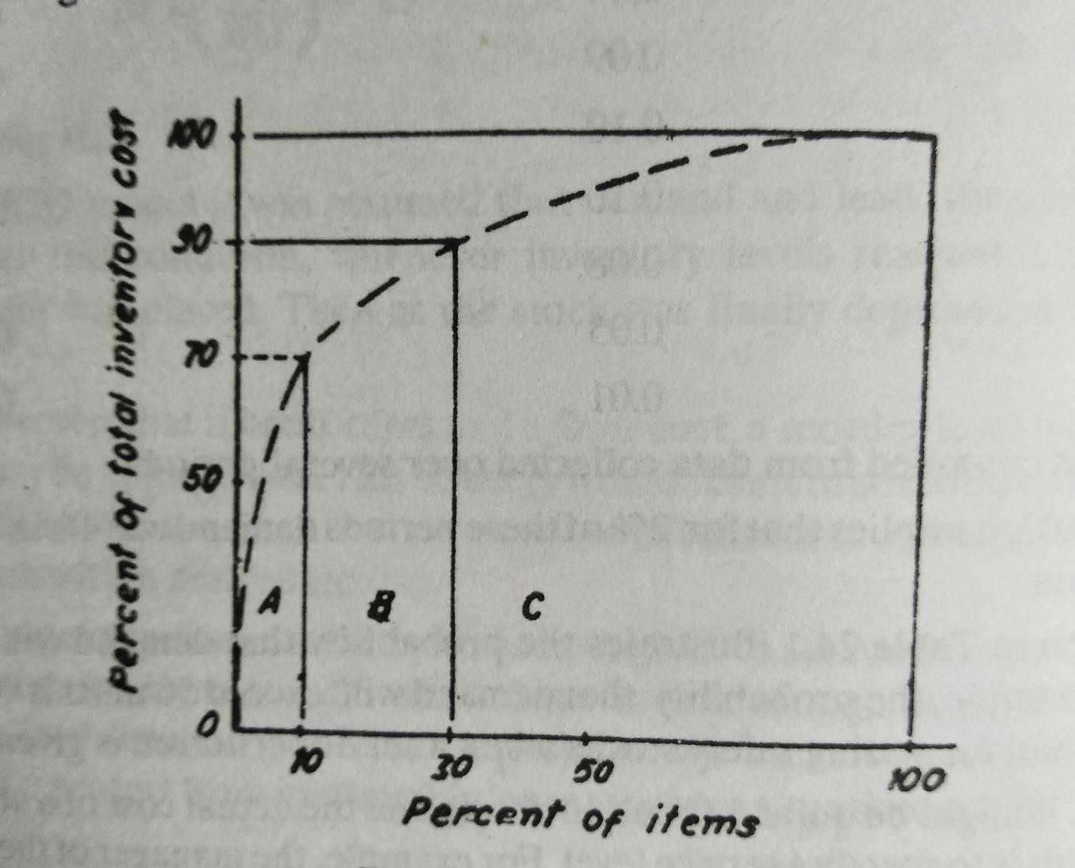

POSSIBLE SHORT QUESTIONS WITH ANSWER
- Define inventory ?

Ans:- Inventory is a detailed list of those movable items which are necessary to manufacturer a product and to maintain the equipment and machinery in good working order.
The quantity and value of every item is also mentioned in the list.

- Define inventory control?

Ans:- Inventory control may also defined as the scientific method of finding out how much stock should be maintained in order to meet the production demands and able to provide right type of material at right time in the right quantity and at competitive prices.

- Define EOQ?
Ans:- EOQ is one of the techniques of inventory control which minimize total Holding and ordering cost of the year.
The EOQ technique can solve the problems of material manager.

POSSIBLE LONG QUESTIONS WITH HINTS

  - Describe the objective and functions of inventory control? Hints :-Refer article no-3.2 and 3.3

  - Define and explain ABC Analysis? Hints :-Refer article no- 3.8

  - Define and explain the EOQ of basic model? Hints :-Refer article no- 3.7

  - Inspection
CHAPTER 4

INSPECTION AND QUALITY CONTROL

It is an activity of measuring, examining, testing one or more characteristics of a product or service and comparing the results with specified requirements in order to establish whether conformity is achieved for each characteristic.

Quality Control
It is an operational technique or a system of maintaining standards by reviewing, checking, inspecting and testing.

Inspection Planning
Inspection plans help us to describe how a quality inspection of one or several materials is to take place. In the inspection plan, we define the sequence of inspection operations and the range of specifications available for inspecting inspection characteristics. Integration
We can integrate the following master data in your inspection plans:
    - QM-specific data
    - Master inspection characteristics to standardize the definition of the characteristics to be inspected.
    - Inspection methods , to define the procedures used in the inspections.
    - Code groups and selected sets , to define codes for results recording.
    - Sampling procedures for sample determination.
    - Dynamic modification rules , to change inspection scopes based on the expected quality level.
    - Other master data
    - Reference operation sets , to structure operations and inspection characteristics.
    - Work center , to define where the inspection is to take place. The work center is also used to settle appraisal costs .
    - Production resources/tools , to define the test equipment to be used. Inspection planning must ensure that the test equipment required for an inspection is available or can be obtained.
    - Change master record with which you can manage various change statuses.
    - Classes in the class system , to classify inspection plans.
    - Scheduling, to check the expected run time and modify it if necessary.
    - Material master records for the materials that are inspected with the inspection plan.
    - Vendor master records , to assign an inspection plan to a material in conjunction with a vendor.

    - Customer master records to assign an inspection plan to a material in conjunction with a customer.
    - Sampling schemes for sample determination.
    - Info records for combinations of material and vendor, or of material, customer and sales organization or purchasing data.

Types Of Inspection
    - There are three primary types of quality inspections: pre-production, in-line, and final. There are a variety of details that must be inspected and approved during each phase in order to detect and correct quality problems.
- Pre-production Inspection:-
    - During the pre-production phase, raw materials should be tested before entering production. This may include a number of tests to examine the material for weight, dimensional stability, pilling resistance, torquing, pile retention, stretch recovery, and much more. Components including closures, zippers, elastics and other embellishments such as beads, rhinestones, sequins and rivets should also be tested for regulatory requirements.
    - Since quality issues are often a result of defects in the materials, inspections during the pre-production phase allow auditors to address any issues before production begins. Ultimately, by inspecting the materials up front, brands and retailers can avoid unanticipated costs and delays.
- In-line Inspection:-
    - Additional inspections should take place during various stages of production. For apparel, inspections should occur at each critical step of the production process, from cutting to assembling to pressing or other finishing procedures. For example, during the cutting phase, each cutting ticket should be randomly inspected to ensure that each part is accurately notched and shades are separated. If fabric is incorrectly cut, the parts cannot be properly assembled.
    - In-line inspections are important, as quality issues are often re-workable during the production phase and can be fixed before the final product is complete. When quality issues are not corrected during the production process, minor issues in the beginning of production can lead to larger issues in later stages.
- Final Inspection:-
    - The final inspection is the last opportunity for auditors to catch and address quality issues before they end up in the hands of the buyer, or even worse, the consumer. During the final audit, products are examined for specific performance requirements, overall appearance, sizing and fit.

    - Brands and retailers often skip inspections while the products are still at the factory and only perform random, final inspections once the order is received at the ultimate destination. By then, it is too late and the only recourse is discarding the poor quality units. This is costly to every party, especially the factory, which will bear the brunt of the expense.

Advantages And Disadvantages Of Quality Control

ADVANTAGES:-
    - It can help to prevent faulty goods and services being sold.
    - It is not disruptive to production- workers continue producing, inspectors do the checking.
    - As with any quality system, the business may benefit from an improved reputation for quality and this may increase sales.
DISADVANTAGES:-
    - It does not prevent waste of resources when products are faulty.
    - The process of inspecting the goods or service costs money, e.g. the wages paid to the inspectors, the cost of testing goods in the laboratory.
    - It does not encourage all workers to be responsible for quality.

Factors that Affect the Quality of Manufactured Products

The factors affecting quality are:
- Money
- Materials
- Management
- People
- Market
- Machines and Methods.
- Money:-Most important factor affecting the quality of a product is the money involved in the production itself. In the present day of tough and cut throat competition, companies are forced to invest a lot in maintaining the quality of products.

- Materials:-To turn out a high quality product, the raw materials involved in production process must be of high quality.
- Management:-Quality control and maintenance programmes should have the support from top management. If the management is quality conscious rather than merely quantity conscious, organisation can maintain adequate quality of products.
- People:-People employed in production, in designing the products must have knowledge and experience in their respective areas.
- Market:-Market for the product must exist before quality of the product is emphasized by management. It is useless to talk about the quality when the market for the product is lacking. For example, there is no demand for woollen garments in the hot climates (e.g., Southern part of India).
- Machines and Methods:-To maintain high standards of quality, companies are investing in new machines and following new procedures and methods these days.

Statistical Quality Control (SQC):-

.

Control charts:
It is graphical presentation of collected information and detects variation in the processing and warns if there is any departure from the specified tolerance limits.

Benefits of using a control chart:-
Control charts can help to understand the variations that are always present in processes. Variations within your control limits indicate that the process is working. Variations that spike outside of your control limits indicate problems that need to be corrected.

- See when something is going wrong or may go wrong. These problem indicators let you know that corrective action needs to be taken.
- Notice patterns within plotted points. The patterns indicate possible causes, which can help you find possible solutions.
- Predict future performance.

- Generate new ideas for improving quality based on your analysis.

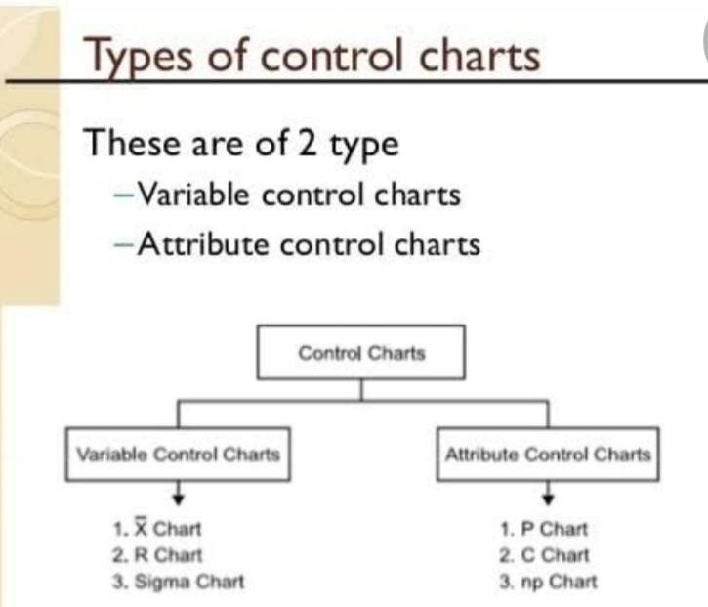

X Bar R Control Charts:-
X bar R chart is used to monitor the process performance of a continuous data and the data to be collected in subgroups at a set time periods. It is actually a two plots to monitor the process mean and the process variation over the time and is an example of statistical process control. These combination charts helps to understand the stability of processes and also detects the presence of special cause variation.
X-bar chart: The mean or average change in process over time from subgroup values.
The control limits on the X-Bar brings the sample’s mean and center into consideration.
R-chart: The range of the process over the time from subgroups values. This monitors the spread of the process over the time.
Interpret the X Bar R Control Charts

- To correctly interpret X bar R chart, always examine the R chart first.
- The X bar chart control limits are derived from the R bar (average range) values, if the values are out of control in R chart that means the X bar chart control limits are not accurate.

- If the points are out of control in R chart, then stop the process. Identify the special cause and address the issue. Remove those subgroups from the calculations.
- Once the R bar chart is in control, then review X bar chart and interpret the points against the control limits.
- All the points to be interpret against the control limits but not specification limits. As specification limits are provided by customer or management whereas control limits are derived from the average and range values of the subgroups.
- If any point out of control in X bar chat. Identify the special cause and address the issue.
- Process capability studies can be performed only after both X bar and R chart values are within the control limits. There is no meaning to perform process capability studies of an unstable process.
  - hart:-
    - It can be a fraction defective chart or % defective chart.
    - Each item is classified as good (non defective ) or bad (defective).
    - This chart is used to control the general quality of the component parts and it checks if the fluctuation in product quality are due to chance cause alone.
    - It can be used even if sample size is variable ,but calculating control limits for each sample is rather cumbersome.
    - P- chart is plotted by calculating first ,the fraction defective and then the control limits. The process is said to be in control if fraction defective values fall within the control limits.
- charts:-
  - It is the control chart in which number of defects in a piece or a sample are plotted.
  - It controls number of defects observed per unit or per sample.
  - Sample size is constant.
  - The chart is used where average number of defects are much less than the number of defects which would occur otherwise if everything possible goes wrong.
  - Where as p-chart considers the no. of defective pieces in a given sample ,c-chart takes into account the no. of defects in each defective piece or in a given sample.
  - The c-chart is preferred for large and complex parts. Such parts being few and limited , however restricts the field of use for c-chart as compared to p-chart.
  - C-chart is plotted in the same manner as p-chart except that the control limits are based on poission distribution.

  - Methods of Attributes

An attribute, as used in quality control, refers to a characteristic that does or does not conform to specifications. For example, in a computer assembly operation, computers are switched on after they have been assembled. They either work (conform) and

undergo further tests or they do not switch on (non conform) in which case they are sent for repair.

Concept of ISO 9001-2008
ISO 9001:2008 is a quality management system standard, first published in 1987 by ISO (International Organization for Standardization). This standard is designed to help organizations ensure that they meet all requirements of customers and stakeholders.
It is neither an industry nor product specific standard. Organizations of all sizes and types can be certified against ISO 9001. This standard can be used by manufacturing or service providing companies. This standard assures quality for all interested parties involved in businesses that are certified.
ISO 9001 is considered as a key factor for doing business in global markets and for improving competitiveness.
The top three countries for the total number of certificates issued are China, Italy and Germany, while the top three for growth in the number of certificates in 2013 are Italy, India and the USA.
It is the most popular standard worldwide and up to the end of December 2013, at least 1, 129, 446 certificates had been issued in 187 countries and economies, three more than in the previous year. The 2013 total represents an increase of 3 % (+32 459) over 2012.
The table below summarizes the statistics of the ISO 9001 certifications around the world.

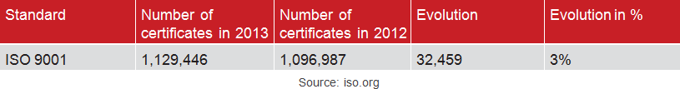
Recent

surveys show that 85% of certified organizations have experienced external benefits, while 95% of them have experienced internal benefits. They also have reported increased customer demand, employee awareness, operational efficiency and higher quality.

An overview of ISO 9001:2008

ISO 9001 specifies requirements for a quality management system where an organization needs to demonstrate its ability to consistently provide products that meet customer and applicable statutory and regulatory requirements; in addition to enhancing customer satisfaction through the effective application of the system, including processes for continual

improvement of the system and assurance of conformity to customer and applicable statutory and regulatory requirements.
All requirements of ISO 9001 are generic and are intended to be applicable to all organizations, regardless of type, size and product provided.

ISO 9001 applies to all types and sizes of organizations that wish to:

- Establish, implement, maintain and improve an QMS;

- Assure conformity with the organization’s stated quality policy;

- Demonstrate conformity to others;

- Seek certification/registration of its QMS by an accredited third party certification body; and
- Make a self-determination and self-declaration of conformity with this International Standard.

Quality management system (QMS)

A quality management system (QMS) is a collection of business processes focused on consistently meeting customer requirements and enhancing their satisfaction. It is aligned with an organization's purpose and strategic direction (ISO9001:2015). It is expressed as the organizational goals and aspirations, policies, processes, documented information and resources needed to implement and maintain it. Early quality management systems emphasized predictable outcomes of an industrial product production line, using simple statistics and random sampling. By the 20th century, labour inputs were typically the most costly inputs in most industrialized societies, so focus shifted to team cooperation and dynamics, especially the early signalling of problems via a improvement cycle. In the 21st century, QMS has tended to converge with sustainability and transparency initiatives, as both investor and customer satisfaction and perceived quality is increasingly tied to these factors. Of QMS regimes, the ISO 9000 family of standards is probably the most widely implemented worldwide – the ISO 19011 audit regime applies to both, and deals with quality and sustainability and their integration.
Other QMS, e.g. Natural Step, focus on sustainability issues and assume that other quality problems will be reduced as result of the systematic thinking, transparency, documentation and diagnostic discipline.
The term "Quality Management System" and the initialise "QMS" were invented in 1991 by Ken Crouched, a British management consultant working on designing and implementing a generic model of a QMS within the IT industry.

Elements

  - Quality objectives
  - Quality manual

  - Organizational structure and responsibilities
  - Data management
  - Processes – including purchasing

  - Product quality leading to customer satisfaction
  - Continuous improvement including corrective and preventive action
  - Quality instrument

  - Document control

Process

A QMS process is an element of an organizational QMS. The ISO 9001:2000 standard
requires organizations seeking compliance or certification to define the processes which form the QMS and the sequence and interaction of these processes. Butterworth-Heinemann and other publishers have offered several books which provide step-by-step guides to those seeking the quality certifications of their products
Examples of such processes include:

  - order processes,

  - production plans,
  - product/ service/ process measurements to comply with specific requirements
e.g. statistical process control and measurement systems analysis,
  - calibrations,
  - internal audits,
  - corrective actions,
  - preventive actions,
  - identification, labelling and control of non-conforming products to prevent its inadvertent use, delivery or processing,
  - purchasing and related processes such as supplier selection and monitoring

ISO9001 requires that the performance of these processes be measured, analyzed and continually improved, and the results of this form an input into the management review process.

BENEFITS OF ISO FOR AN ORGANIZATION
Some of the main benefits of ISO 9001 certification include:

  - Increased efficiency – Implement processes and procedures which are based on a quality focus.
  - Increased revenue – win more contracts and tenders, whilst streamlining your processes and identifying opportunities for cost savings.
  - Greater employee morale – by ensuring that all employees are working to one agenda you can reduce errors and increase productivity.
  - International recognition – recognised in approximately 188 countries, ISO 9001 can help you to access international trade.
  - Factual approach to decision making – ensure the business decisions you make are beneficial long term by basing them on facts.
  - Better supplier relationships – business has credibility through the reputation of ISO 9001, providing suppliers with greater confidence in what you do.
  - Improved record keeping – as with any management system, ISO 9001 ensures you document your processes from start to finish. Helping you to handle customer complaints and improve process efficiency.
  - Improved customer satisfaction – ensure you have a feedback system in place which will help you to understand your customers’ needs, identify areas for improvement and reduce wasted resources.
  - Continuous improvement – using non-conformity reporting and trend analysis, you can spot areas for improvement and stay ahead of the competition.

Benefits of ISO 9001 for customers:
  - Improved quality of service – this also comes with the benefit of increased on time delivery
  - Reduced need for returns – because issues are identified and resolved quicker, often without the customer knowing
  - Assurance of service – certification acts as proof that the organisation provide consistent, reliable and fit for purpose solutions
  - Improved experience – improving the relationship between customers/stakeholders and the organisation will create a better customer experience and increase the chances of the customer returning again in future.

Just-In-Time (JIT)
The just-in-time (JIT) inventory system is a management strategy that aligns raw-material orders from suppliers directly with production schedules. Companies employ this inventory strategy to increase efficiency and decrease waste by receiving goods only as

they need them for the production process, which reduces inventory costs. This method requires producers to forecast demand accurately.
      - The just-in-time (JIT) inventory system is a management strategy that minimizes inventory and increases efficiency.
      - Just-in-time manufacturing is also known as the Toyota Production System (TPS) because the car manufacturer Toyota adopted the system in the 1970s.
      - Kanban is a scheduling system often used in conjunction with JIT to avoid overcapacity of work in process.
      - The success of the JIT production process relies on steady production, high-quality workmanship, no machine breakdowns, and reliable suppliers.

Benefits of Just-in-Time Manufacturing
      - When done well, adopting a Lean manufacturing or just in time manufacturing system can have a drastic impact on an organization’s productivity, risk management, and operating costs. Here are just a few of the quantitative benefits experienced by manufacturers worldwide:
      - Reduction in inventory
      - Reduction in labour costs
      - Reduction in space needed to operate
      - Reduction in WIP (work in process)
      - Increase in production
      - Improvements in product quality (lower rates of defects)
      - Reduction of throughput time
      - Reduction of standard hours
      - Increase in number of shipments

Six Sigma() What is Six Sigma?
Six Sigma actually has its roots in a 19th Century mathematical theory, but
found its way into today’s mainstream business world through the efforts of an engineer at Motorola in the 1980s. Now heralded as one of the foremost methodological practices for improving customer satisfaction and improving business processes, Six Sigma has been refined and perfected over the years into what we see today.

How Six Sigma Began
- In the 19th century, German mathematician and physicist Carl Fredrich Gauss developed the bell curve. By creating the concept of what a normal distribution looks like, the bell curve became an early tool for finding errors and defects in a process.

- In the 1920s, American physicist, engineer and statistician Walter Shewhart expanded on this idea and demonstrated that “sigma imply where a process needs improvement,” according to “The Complete Business Process Handbook: Body of Knowledge From Process Modelling to BPM Vol. 1” by Mark von Rosing, August- Wilhelm Scheer and Henrik von Scheel.
- In the 1980s, Motorola brought Six Sigma into the mainstream by using the methodology to create more consistent quality in the company’s products, according to “Six Sigma” by Mikel Harry and Richard Schroeder.
- Motorola engineer Bill Smith eventually became one of the pioneers of modern Six Sigma, creating many of the methodologies still associated with Six Sigma in the late 1980s. The system is influenced by, but different than, other management improvement strategies of the time, including Total Quality Management and Zero Defects.

What Six Sigma Means
- Experts credit Shewhart with first developing the idea that any part of process that deviates three sigma from the mean requires improvement. One sigma is one standard deviation.
- The Six Sigma methodology calls for bringing operations to a “six sigma” level, which essentially means 3.4 defects for every one million opportunities. The goal is to use continuous process improvement and refine processes until they produce stable and predictable results.
- Six Sigma is a data-driven methodology that provides tools and techniques to define and evaluate each step of a process. It provides methods to improve efficiencies in a business structure, improve the quality of the process and increase the bottom-line profit.

The Importance of People in Six Sigma
- A key component of successful Six Sigma implementation is buy-in and support from executives. The methodology does not work as well when the entire organization has not brought in.
- Another critical factor is the training of personnel at all levels of the organization. White Belts and Yellow Belts typically receive an introduction to process improvement theories and Six Sigma terminologies. Green Belts typically work for Black Belts on projects, helping with data collection and analysis. Black Belts lead projects while Master Black Belts look for ways to apply Six Sigma across an organization.

Methodologies of Six Sigma
There are two major methodologies used within Six Sigma, both of which are composed of five sections, according to the 2005 book “JURAN Institute Six Sigma Breakthrough and Beyond” by Joseph A. De Feo and William Barnard.
DMAIC: The DMAIC method is used primarily for improving existing business processes. The letters stand for:
- Define the problem and the project goals
- Measure in detail the various aspects of the current process
- Analyze data to, among other things, find the root defects in a process

- Improve the process
- Control how the process is done in the future

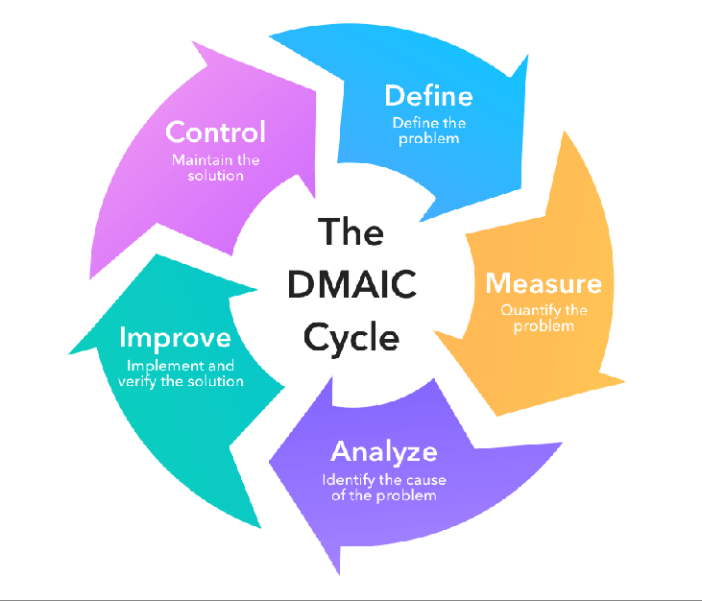

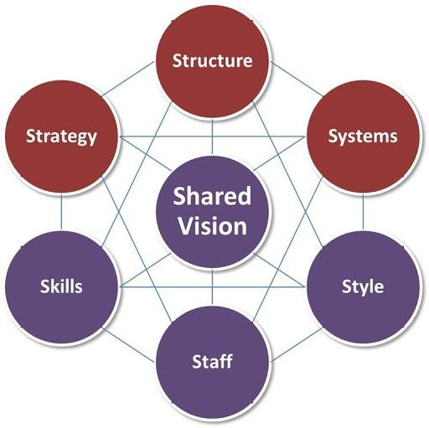
7s:-
The McKinsey 7S Model refers to a tool that analyzes a company’s “organizational design.” The goal of the model is to depict how effectiveness can be achieved in an organization through the interactions of seven key elements – Structure, Strategy, Skill, System, Shared Values, Style, and Staff.
Structure of the McKinsey 7S Model
Structure, Strategy, and Systems collectively account for the “Hard Ss” elements, whereas the remaining are considered “Soft Ss.”
- Structure:- Structure is the way in which a company is organized – chain of command and accountability relationships that form its organizational chart.
- Strategy:- Strategy refers to a well-curated business plan that allows the company to formulate a plan of action to achieve a sustainable competitive advantage, reinforced by the company’s mission and values.
- Systems:-Systems entail the business and technical infrastructure of the company that establishes workflows and the chain of decision-making.
- Skills:-Skills form the capabilities and competencies of a company that enables its employees to achieve its objectives.

- Style:-The attitude of senior employees in a company establishes a code of conduct through their ways of interactions and symbolic decision-making, which forms the management style of its leaders.
- Staff:-Staff involves talent management and all human resources related to company decisions, such as training, recruiting, and rewards systems
- Shared Values:- The mission, objectives, and values form the foundation of every organization and play an important role in aligning all key elements to maintain an effective organizational design.

Lean manufacturing:-
Lean manufacturing is a production process based on an ideology of maximising productivity while simultaneously minimising waste within a manufacturing operation. The lean principle sees waste is anything that doesn’t add value that the customers are willing to pay for.The benefits of lean manufacturing include reduced lead times and operating costs and improved product quality.
How Does Lean Manufacturing Work?
The core principle in implementing lean manufacturing is to eliminate waste to continually improve a process. By reducing waste to deliver process improvements, lean manufacturing sustainably delivers value to the customer.
The types of waste include processes, activities, products or services that require time, money or skills but do not create value for the customer. These can cover underused talent, excess inventories or ineffective or wasteful processes and procedures.
Removing these inefficiencies should streamline services, reduce costs and ultimately provide savings for a specific product or service through the supply chain to the customer.

The 5 Principles of Lean manufacturing:-
- Value: Value is determined from the perspective of the customer and relates to how much they are willing to pay for products or services. This value is then created by the manufacturer or service provider who should seek to eliminate waste and costs to meet the optimal price for the customer while also maximising profits.
- Map the Value Stream: This principle involves analysing the materials and other resources required to produce a product or service with the aim of identifying waste and improvements. The value stream covers the entire lifecycle of a product, from raw materials to disposal. Each stage of the production cycle needs to be examined for waste and anything that doesn’t add value should be removed. Chain alignment is often recommended as a means to achieve this step.
Modern manufacturing streams are often complex, requiring the combined efforts of engineers, scientists, designers and more, with the actual manufacturing of a physical product being just one part of a wider stream of work.
- Create Flow: Creating flow is about removing functional barriers to improve lead times. This ensures that processes are smooth and can be undertaken with minimal delay or other waste. Interrupted and disharmonious production processes incur costs and creating flow means ensuring a constant stream for the production or service delivery.
- Establish a Pull System: A pull system works by only commencing work when there is demand. This is the opposite of push systems, which are used in manufacturing resource

planning (MRP) systems. Push systems determine inventories in advance with production set to meet these sales or production forecasts. However, due to the inaccuracy of many forecasts, this can result in either too much or not enough of a product being produced to meet demand. This can lead to additional warehousing costs, disrupted schedules or poor customer satisfaction. A pull system only acts when there is demand and relies on flexibility, communication and efficient processes to be successfully achieved.
The pull system can involve teams only moving onto new tasks as the previous steps have been completed, allowing the team to adapt to challenges as they arise in the knowledge that the prior work is mostly still applicable to delivering the product or service.
- Perfection: The pursuit of perfection via continued process improvements is also known as ‘Kaizen’ as created by Toyota Motor Corporation founder Kiichiro Toyoda.Lean manufacturing requires ongoing assessment and improvement of processes and procedures to continually eliminate waste in an effort to find the perfect system for the value stream. To make a meaningful and lasting difference, the notion of continuous improvement should be integrated through the culture of an organisation and requires the measurement of metrics such as lead-times, production cycles, throughput and cumulative flow.

Advantages and Disadvantages
Lean manufacturing carries several advantages and disadvantages depending on how and where it is implemented.

Advantages:
- Saves Time and Money
Cost-saving is the most obvious advantage of lean manufacture. More efficient workflows, resource allocation, production and storage can benefit businesses regardless of size or output. Time saving allows for reduced lead times and better service in providing products quickly to customers, but can also help save money through allowing for a more streamlined workforce.
- Environmentally Friendly
Reducing waste in time and resources and removing unnecessary processes can save the costs in energy and fuel use. This has an obvious environmental benefit, as does the use of more energy efficient equipment, which can also offer cost savings.
- Improved Customer Satisfaction
Improving the delivery of a product or service, at the right cost, to a customer improves customer satisfaction. This is essential to business success as happy customers are more likely to return or recommend your product or service to others.

Disadvantages:
- Employee Safety and Wellbeing
Critics of lean argue that it can ignore employee safety and wellbeing. By focussing on removing waste and streamlining procedures it is possible to overlook the stresses placed on employees who are given little margin for error in the workplace. Lean has been compared to 19th Century scientific management techniques that were fought against by labour reforms and believed obsolete by the 1930s.
- Hinders Future Development

Lean manufacturing’s inherent focus on cutting waste can lead management to cut areas of a company that are not deemed essential to current strategy. However, these may be important to a company’s legacy and future development. Lean can create an over-focus on the present and disregard the future.
- Difficult to Standardise
Some critics point out that lean manufacturing is a culture rather than a set method, meaning that it is impossible to create a standard lean production model. This can create a perception that lean is a loose and vague technique rather than a robust one.

4.9.4. problems:- Problem 01:

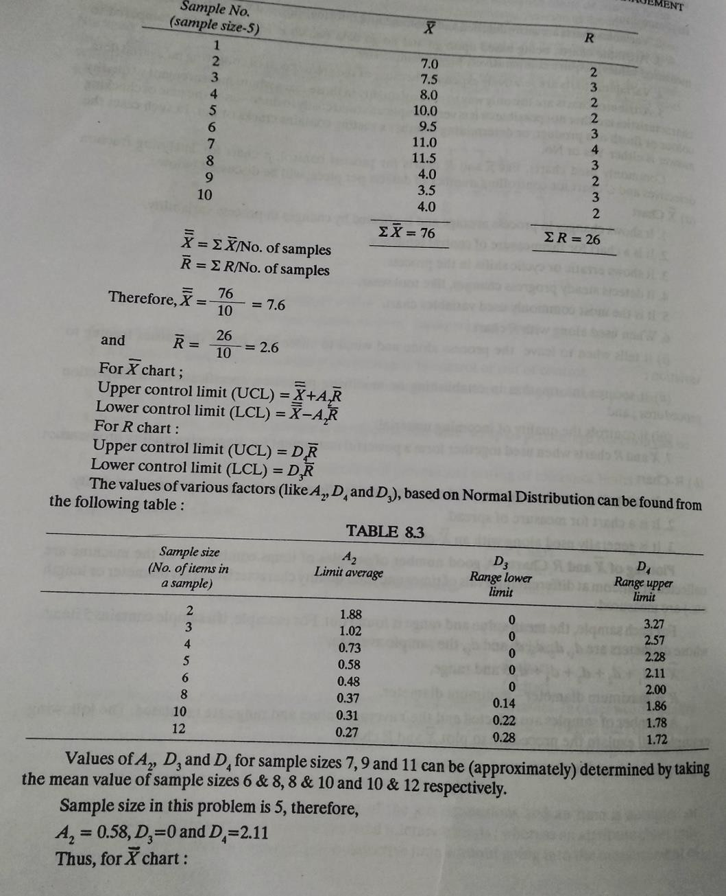
problem 01:-

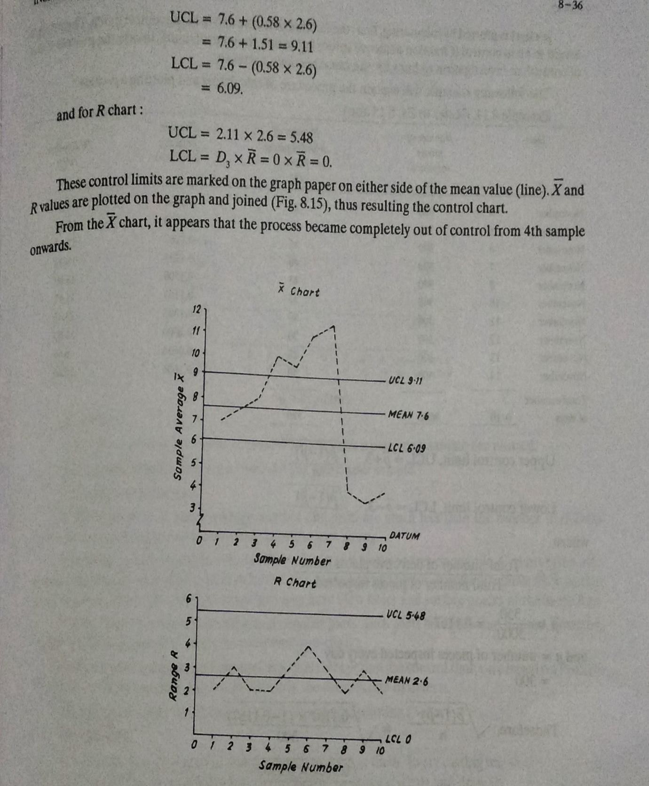

Problem 02:-
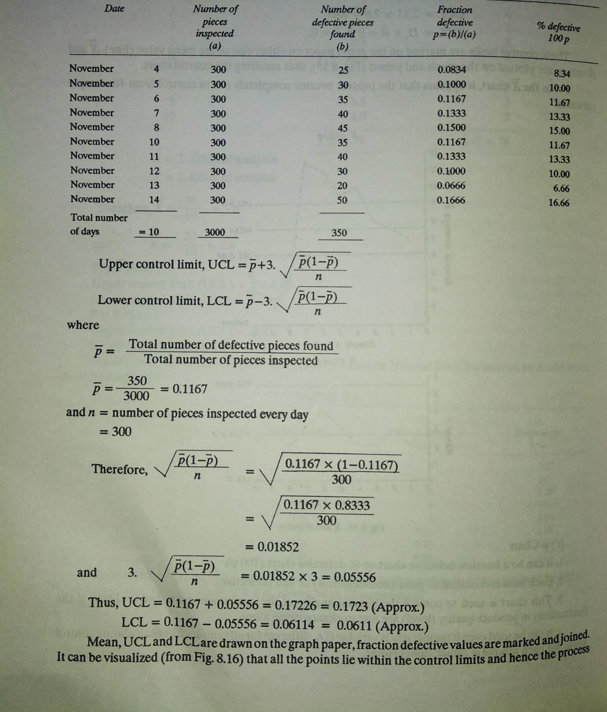

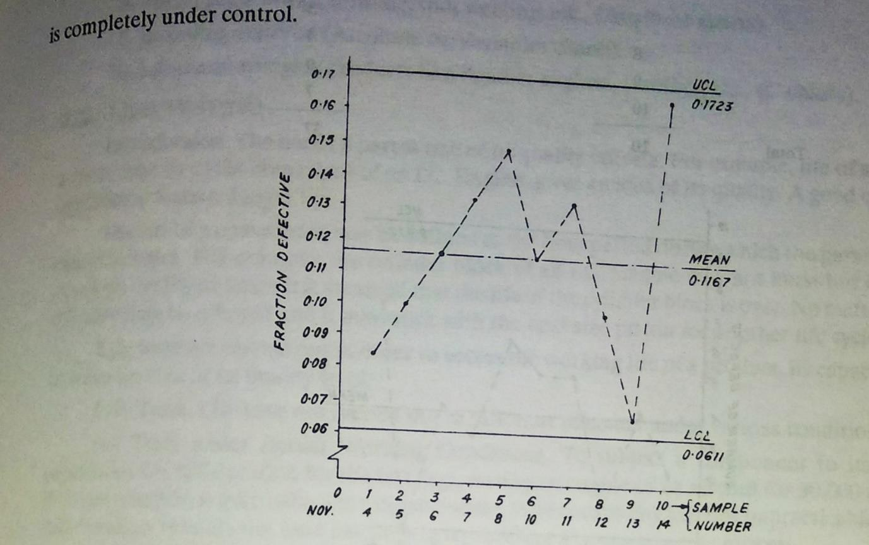
Problem no 03:-
Ten castings were inspected in order to locate defects in them. Every casting was found to contain certain no of defects as given below. It is required to plot a c-chart and draw the conclusion.

Castings | No of defects found on inspection (c)
1 | 2
2 | 4
3 | 1
4 | 5
5 | 5
6 | 6
7 | 3
8 | 4
9 | 0
10 | 7
Total | 37

Solution:-

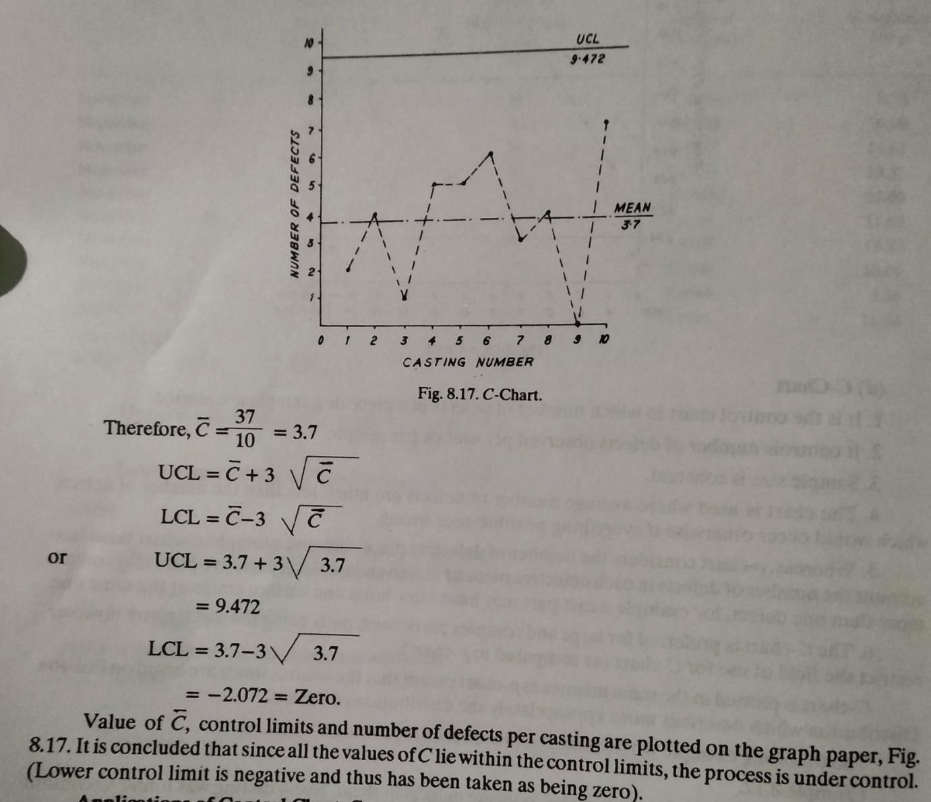

Possible short questions with answers:-
- Define control charts?
Ans:- It is graphical presentation of collected information and detects variation in the processing and warns if there is any departure from the specified tolerance limits.
- Define lean manufacturing ?
Ans:- Lean manufacturing is a production process based on an ideology of maximising productivity while simultaneously minimising waste within a manufacturing operation. The lean principle sees waste is anything that doesn’t add value that the customers are willing to pay for.The benefits of lean manufacturing include reduced lead times and operating costs and improved product quality.
- Define inspection and quality control ? Ans:- Inspection
It is an activity of measuring, examining, testing one or more characteristics of a
product or service and comparing the results with specified requirements in order to establish whether conformity is achieved for each characteristic.

Quality Control
It is an operational technique or a system of maintaining standards by reviewing, checking, inspecting and testing.
- What is six sigma ?
Ans:- The Six Sigma methodology calls for bringing operations to a “six sigma” level, which essentially means 3.4 defects for every one million opportunities. The goal is to use continuous process improvement and refine processes until they produce stable and predictable results.
- Write the different types of control charts? Ans:-
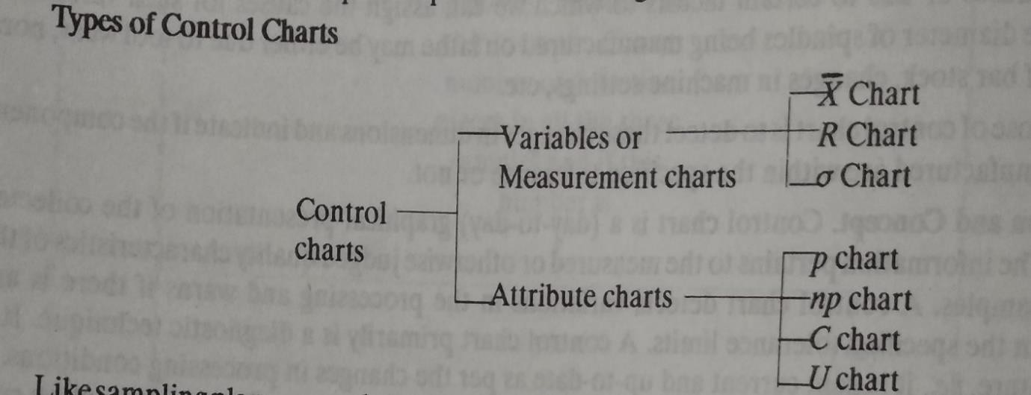

Possible long questions with hints:-
- Describe planning of inspection? Hints: refer article no-4.3

- Describe the factors influencing the quality of manufacturing? Hints: refer article no-4.5
- Write short notes on: lean manufacturing, 7s,six -sigma ? Hints:-refer article no 4.9.3

………………………………………………….

CHAPTER 05

PRODUCTION PLANNING AND CONTROL
  - Introduction:-
Production planning and control refers to two strategies that work cohesively throughout the manufacturing process. Production planning involves what to produce, when to produce it, how much to produce, and more. A long-term view of production planning is necessary to fully optimize the production flow.
Production control uses different control techniques to reach optimum performance from the production system to achieve throughput targets.

:- Major function of Production planning and control:-
    - Improved organization for regular and timely delivery
    - Better supplier communication for raw materials procurement
    - Reduced investment in inventory
    - Reduced production cost by increasing efficiency
    - Smooth flow of all production processes
    - Reduced waste of resources
    - Production cost savings that improve the bottom line

Forecasting:-
Forecasting is a technique that uses historical data as inputs to make informed estimates that are predictive in determining the direction of future trends. Businesses utilize forecasting to determine how to allocate their budgets or plan for anticipated expenses for an upcoming period of time.
Being able to accurately predict future trends and events is useful in many contexts, including business management. Forecasting is important because it can be used for:
- Estimating the success of a new business venture:-When starting a new business, proper forecasting can reveal crucial information that may determine the company's future success. Forecasting reveals some of the risks and uncertainties that a new business faces and can offer an entrepreneur the right tools to anticipate elements such as the strength of the competition, demand potential for a product or service and future industry development.
- Estimating financial necessities:- Estimating a company's future financial requirements is one of the most important uses of forecasting. It can help a company determine its financial future by estimating future sales, the capital needed for future product development, the costs of future expansions and other estimated expenses that are used to estimate future costs.
- Ensuring the company's operational consistency:- Proper forecasting can reveal important information regarding future earnings and spending. By having an estimate of the funds going in and out of the organization over a certain period of time, the company's management can make more efficient and accurate plans for the future.
- Helping managers make the right decisions:- A significant proportion of management decisions are made by relying on accurate forecasting. Most businesses, regardless of

size, face several potential uncertainties — such as seasonal rises and falls in sales, changes in personnel and changes in raw material prices — depending on the exact nature and purpose of the organization. Forecasting plays a major role in providing managers with the information they need to make informed decisions regarding the company's future.
- Increasing a business venture's odds of success:-The success of a business often depends on fine margins and correct fund allocation. Forecasting can predict important metrics, like the amount of needed raw materials, the right budget for each company department and the number of future sales. These figures help management allocate funds and resources and prioritize one product or service over another, depending on the type of company and the forecasted data.
- Formulating effective plans for the future:-All planning implies the use of forecasts, making forecasting a very important element of formulating realistic and helpful plans. Any form of planning, from short-term to long-term, is heavily reliant on forecasting, creating a direct link between accurate forecasting and adequate planning.
- Promoting workplace cooperation:-Gathering and analyzing the data required for forecasting typically requires coordination and collaboration between all the company's department managers, as well as other employees. This makes the whole process a collaboration, increasing team spirit and cohesion.
- Helping an organization improve:-Forecasting gives managers information that they can use to spot any weakness in the organization's processes. By discovering potential shortcomings ahead of time, the company's managers have the proper tools to correct any weakness before they affect the profits.

The Goal Of The Forecast:-
This determines the required level of accuracy and helps identify the most appropriate forecasting techniques. A broad decision, like deciding whether or not to enter a new market, can be done by roughly estimating the future size of that market. On the other hand, a more delicate decision, such as determining the right budget for each department, requires a more detailed and accurate approach.

Methods of forecasting
There are four main forecasting methods that you can use to determine future values, revenues, expenses, costs, trends and other similar indicators. They are:
- Straight-line method: This is the easiest forecasting method, both to learn and to follow. It's typically used by financial analysts to determine future revenues based on past trends and figures.
- Moving average: This technique analyzes the underlying pattern of a dataset to estimate future values. The most widely-used types are the three-month and the five- month moving average.
- Simple linear regression: It is especially useful when analyzing the connection between different variables, to get a more accurate prediction.
- Multiple linear regression: It is mainly used for forecasting revenues, in situations where two or more independent variables are needed for a projection.

Routing:-
- Routing lays down the flow of work in the plant. It determines what work is to be done and where and how it will be done. Taking from raw material to the finished product, routing decides the path and sequence of operations to be performed on the job from one machine to another. The purpose of Routing is to establish the optimum sequence of operations. Routing in production management is related to considerations of layout, temporary storage of in-process inventory and material handling.
- Routing in continuous industries does not present any problem because of the product type of layout, where the equipment is laid as per the sequence of operations required to be performed on the components (from raw material to the finished products). In open job shops, since, every time the job is new, though operation sheets (sometimes) may serve the purpose, but the route sheets will have to be revise and this involves a greater amount of work and expertise.

Routing Procedure
Various procedural steps of Routing in production management are as follows:
- The finished product is analyzed from the manufacturing standpoint in order to decide how many components can be made in the plant and how many others will be purchased (Make/Buy decision) from outside through vendors, by subcontracting, etc. Make/Buy decision depends upon the work load in the plant, availability of equipment and personnel to manufacture all components, and the economy associated with making all components within the plant itself.
- A parts list and a bill of materials is prepared showing name of the part, quantity, material specifications, amount of materials required, etc. The necessary materials thus can be procured.
- From production standards, machine capacities, machine characteristics and the operations which must be performed at each stage of manufacture are established and listed in proper sequence on an operation and route sheet. The place where these operations will be performed is also decided. Actually, operation sheet and route sheet are separate. An operation sheet shows every thing about the operations, i.e., operation description, their sequence, type of machinery, tools, set up and operation times, whereas a route sheet besides the sequence of operations and relation between operation and machine, also details the section (department) and the machines to whom the work will flow. The difference between an operation sheet and a route sheet is that an operation sheet remains same for the components if the order is repeated but the route sheet may have to be revised if certain machines are already committed to other orders (jobs) on hand. Except this small difference, both the sheets contain practically the same information and thus are generally combined into one sheet known as ‘operation and route sheet’.
- The next step is to determine the lot size or the number of components to be manufactured in one lot or batch. In the case of an order from a particular customer, it is generally equal to a number within 10% of the order quantity. In other cases the principle of economic batch quantity can be applied to determine the batch size.
- Standard scrap factors (single or cumulative) and the places (i.e., after a particular operation or assembly) where scrap is very likely to occur are identified. The actual scrap in each batch can be recorded on the control chart. Causes for points out of control limits are explored and corrected. The variables like workers, machinery and schedules may also be adjusted to minimize scrap.

- The cost of the component is analyzed and estimated through the information obtained in steps (1) to (5) above. The cost consists of material and labour charges, and other specific and general indirect expenses.

Scheduling:-
- Scheduling is the process of arranging, controlling and optimizing work and workloads in a production process or manufacturing process. Scheduling is used to allocate plant and machinery resources, plan human resources, plan production processes and purchase materials.
- It is an important tool for manufacturing and engineering, where it can have a major impact on the productivity of a process. In manufacturing, the purpose of scheduling is to minimize the production time and costs, by telling a production facility when to make, with which staff, and on which equipment. Production scheduling aims to maximize the efficiency of the operation and reduce costs.

- Forward scheduling is planning the tasks from the date resources become available to determine the shipping date or the due date.
- Backward scheduling is planning the tasks from the due date or required-by date to determine the start date and/or any changes in capacity required.
The benefits of production scheduling include:
- Process change-over reduction
- Inventory reduction, levelling
- Reduced scheduling effort
- Increased production efficiency
- Labour load levelling
- Accurate delivery date quotes
- Real time information

Concepts of scheduling:-
A key character of scheduling is the productivity, the relation between quantity of inputs and quantity of output. Key concepts here are:
  - Inputs : Inputs are plant, labour, materials, tooling, energy and a clean environment.
  - Outputs : Outputs are the products produced in factories either for other factories or for the end buyer. The extent to which any one product is produced within any one factory is governed by transaction cost.
  - Output within the factory : The output of any one work area within the factory is an input to the next work area in that factory according to the manufacturing process. For example, the output of cutting is an input to the bending room.

  - Output for the next factory : By way of example, the output of a paper mill is an input to a print factory. The output of a petrochemicals plant is an input to an asphalt plant, a cosmetics factory and a plastics factory.
  - Output for the end buyer : Factory output goes to the consumer via a service business such as a retailer or an asphalt paving company.
  - Resource allocation : Resource allocation is assigning inputs to produce output. The aim is to maximize output with given inputs or to minimize quantity of inputs to produce required output.

Dispatching:-
      - Dispatching is the routine of setting productive activities in motion through the release of orders and necessary instructions according to pre-planned times and sequence of operations embodied in route sheets and loading schedules.
      - In other words, once a job is in an area where an operation is to be performed, it has to be determined when and by whom the job will be processed and also the sequence of waiting orders to be processed. The decision of assigning the various jobs to different machines and equipment is called Dispatching.

Functions of Dispatching:
- To check the availability of input materials and ensure the movement of material from store to first process and then from process to process.
- To ensure the availability of all production and inspection aids.
- To obtain the requisite drawings, specifications and material lists.
- To assign the work appropriate machine, workplace and men.
- The issue of job orders authorising operations in accordance with dates and times previously planned and entered on load charts and route sheets.
- The issue of time tickets, instruction cards and other required items to the workers who are to perform the various activities.
- The issue of inspection orders after each operation in order to determine result regarding the quality of products if excessive spoilage occurs, to find out its causes.

Dispatching Procedure:

The product is broken into different components and components into operations.

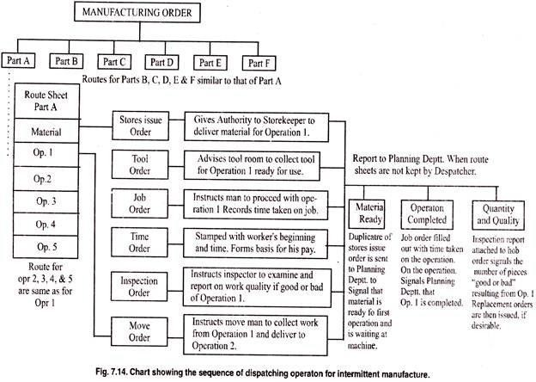

- Store Issue Order: Authorize stores (department) to deliver required raw material.
- Tool Order: Authorize tool store to release the necessary tools. The tools can be collected by the tool room attendant.
- Job Order: Instruct the worker to proceed with the operation.
- Time Ticket: It records the beginning and ending time of the operations and forms the basis for worker’s pay.
- Inspection Order: Notify the inspectors to carried out necessarily inspections and report the quality of the component.
- Move Order: Authorize the movement of materials and components from one facility (machine) to another for further operations.
In addition, there are certain other dispatch aspects which have to be taken care of:
  - All production information should be available before hand.
  - Various order cards, and specification drawings should be ready.
  - Equipments should be ready for use.
  - Progress of various orders should be properly recorded on the Gantt charts or display boards.
  - All production records should be properly maintained.

Centralized And Decentralized Dispatching

Dispatch function may be centralized or decentralized.

In a Centralized dispatch system, a central dispatching department, orders directly to the work station. It maintains a full record of the characteristics and capacity of each equipment and work load against each machine. The orders are given to the shop supervisor, who runs his machines accordingly. In most of the cases, the supervisor can also give suggestions as regards loading of men and machines under him. A centralized dispatching system has the following advantages:

- A greater degree of overall control can be achieved.
- Effective co-ordination between different facilities is possible.
- It has greater flexibility
- Because of urgency of orders, changes in schedules can be affected rapidly without upsetting the whole system.
- Progress of orders can be readily assessed at any time because all the information is available at a central place.
- There is effective and better utilization of manpower and machinery.

In a Decentralized dispatching system the shop supervisor performs the dispatch factions. He decides the sequence of handling different orders. He dispatches the orders and materials to each equipment and worker, and is required to complete the work within the prescribed duration. In case he suspects delay, with due reasons of the same, he informs the production control department. A decentralized dispatching system has the following advantages.

- Much of the red tape is minimized
- Shop supervisor knows best about his shop, therefore, the work can be accomplished by the most appropriate worker and the machine.
- Elaborate reports and duplication of postings can be avoided
- Communication gap is reduced
- It is easy to solve day-to-day problems
- It keeps the natural urge of a section to be self-sufficient.

:- Controlling

The production control is the function of management which plans, directs and controls the material supply and processing activities of an enterprise so that specified products are produced by specified methods to meet an approved sales programme. It ensures that activities are carried out in such a way that the available labour and capital are used in the best possible way.

The British Standards Institute defines the term production control to include the following:

- The production plan or planning
- Scheduling
- Machine or labour utilization or dispatching
- Stock control
- Manufacturing control or routing and
- Progress

Objectives :-

- Issuing the necessary orders to the proper personnel through the prescribed channels for effecting the plan.

- To ensure availability of the means of carrying out the orders — the materials, machines, tools, equipment and manpower — in the required quality at the required time.

- To ensure carrying out of the orders by the personnel so that goods are produced in the required quantities of the specified quality at the pre-determined time. Thus, the underlying principle of production control is that the highest efficiency in production is obtained by producing the required in time and in the best and cheapest method possible.

Functions :-

Following factors are involved in the practice of production control:

- Control Activities

This is done by releasing manufacturing orders through dispatching. Thus, plans are set in motion at the assigned time.

- Control of Material Movement

The time at which material is received from the supplier, and issued to the plant is observed and a close watch is kept on its movement from one plant to another to ensure that this movement is in accordance with the production cost.

- Availability of Tools is Controlled

Steps are to be taken to ensure that tools specified in the production plan are available as and when required.

- Quantity Produced is Controlled

Work-in-process at pre-determined stages of production is observed to determine that right quantity of specified quality work is processed.

- Control of Replacement

Quantity of raw material and work-in-process which fails to pass each stage of inspection is observed. Provision is made to issue replacement orders for each material for work.

- Labour Efficiency and Control

Time taken on each unit of work-in-process is observed and recorded. Comparison of time taken is made with the time allowed in scheduling.

Advantages:-

A good production control system means more production on the same investment without unduly speeding up workers. The advantages of production planning and control are given below:

- Better service to customers

Promised delivery dates are kept, production flows as per scheduled time. This injects confidence in the traveling salesmen of the firm to set delivery date. Timely delivery and customers’ confidence, improve customer-relations and sales.

- Less overtime work

As production takes place as per schedule, there will be few rush orders. Therefore, there will be less overtime work in the organization, compared to other firms in the same industry.

- Need of smaller inventories of work-in-process and of finished goods

Enterprise working under an effective production planning and control system require lower inventories of material, parts, components, etc., for work-in-process and less of finished goods in stocks. This results in less investment in inventory. Funds thus freed may be put to other more income-earning uses. Also, orders of customers can be supplied in full. This would bring the benefits of economy in transport costs too.

- More Effective Purchasing

As better materials management lead to effective inventory control, purchasing is more scientific, economical and timely.

- More effective use of equipment

Management is constantly kept informed on the current position of all work-in-process and on equipment and personnel requirements for the next few weeks ahead. Therefore, workers can be informed in advance of possible lay-offs, transfers etc. Also belated purchase of equipment and materials can be avoided and idleness of men and machine eliminated.

- Less loss of time

  - Because of phased flow of material, workers need not wait for the material for long. Hence, there will be less of workmen hours.

  - The time of management staff is conserved in two ways.

First, their personal attention is drawn only when there is any serious flaw in the working of the system. Secondly, they need not spend much time on research and analysis of data, etc., required for long-range planning as they can proceed to prepare such plans for expansion on the basis of the data made available by the production planning and control system.

- Savings in the cost

A properly designed and introduced system of production planning and control results in major cost-savings.

- Less work-stoppages

Work-stoppages are avoided or minimized in terms of time-duration. Therefore, delay occurring in the dispatch of goods to customers is very rare.

:- Types Of Production

Some of the most important types of production are: (i) Job order Production (ii) Batch production and (iii) Mass or flow production.

A production manager will have to choose most appropriate method for his enterprise.

Mass or flow production:

This method involves a continuous production of standardized products on a large scale. Under this method, production remains continuous in anticipation of future demand. Standardization is the basis of mass production. Standardized products are produced under this method by using standardized materials and equipment. There is a continuous or uninterrupted flow of production obtained by arranging the machines in a proper sequence of operations. Process layout is best suited method for mass production units.

Flow production is the manufacture of a product by a series of operations, each article going on to a succeeding operation as soon as possible. The manufacturing process is broken into separate operations.

The product completed at one operation is automatically passed on to the next till its completion. There is no time gap between the work done at one process and the starting at the next. The flow of production is continuous and progressive.

Characteristics:

The mass or flow production possesses the following characteristics.

- The units flow from one operation point to another throughout the whole process.

- There will be one type of machine for each process.

- The products, tools, materials and methods are standardised.

- Production is done in anticipation of demand.

- Production volume is usually high.

- Machine set ups remain unchanged for a considerable long period.

- Any fault in flow of production is immediately corrected otherwise it will stop the whole production process.

Suitability of flow/mass production:

- There must be continuity in demand for the product.

- The products, materials and equipment must be standardised because the flow of line is inflexible.

- The operations should be well defined.

- It should be possible to maintain certain quality standards.

- It should be possible to find time taken at each operation so that flow of work is standardised.

- The process of stages of production should be continuous.

Advantages of mass production:

A properly planned flow production method, results in the following advantages:

- The product is standardised and any deviation in quality etc. is detected at the spot.

- There will be accuracy in product design and quality.

- It will help in reducing direct labour cost.

- There will be no need of work-in-progress because products will automatically pass on from operation to operation.

- Since flow of work is simplified there will be lesser need for control.

- A weakness in any operation comes to the notice immediately.

- There may not be any need of keeping work-in-progress, hence storage cost is reduced.

Batch production:

Batch production pertains to repetitive production. It refers to the production of goods, the quantity of which is known in advance. It is that form of production where identical

products are produced in batches on the basis of demand of customers’ or of expected demand for products.

This method is generally similar to job production except the quantity of production. Instead of making one single product as in case of job production, a batch or group of products are produced at one time. It should be remembered here that one batch of products may not resemble with the next batch.

Under batch system of production the work is divided into operations and one operation is done at a time. After completing the work on one operation it is passed on to the second operation and so on till the product is completed. Batch production can be explained with the help of an illustration. An enterprise wants to manufacture 20 electric motors.

The work will be divided into different operations. The first operation on all the motors will be completed in the first batch and then it will pass on to the next operation. The second group of operators will complete the second operation before the next and so on. Under job production the same operators will manufacture full machine and not one operation only.

Batch production can fetch the benefits of repetitive production to a large extent, if the batch is of a sufficient quantity. Thus batch production may be defined as the manufacture of a product in small or large batches or lots by series of operations, each operation being carried on the whole batch before any subsequent operation is operated. This method is
generally adopted in case of biscuit and confectionery and motor manufacturing, medicines, tinned food and hardware’s like nuts and bolts etc.

Characteristics:

- The work is of repetitive nature.

- There is a functional layout of various manufacturing processes.

- One operation is carried out on whole batch and then is passed on to the next operation and so on.

- Same type of machines is arranged at one place.

- It is generally chosen where trade is seasonal or there is a need to produce great variety of goods.

Job order Production

Under this method peculiar, special or non-standardized products are produced in accordance with the orders received from the customers. As each product is non- standardized varying in size and nature, it requires separate job for production. The machines and equipment’s are adjusted in such a manner so as to suit the requirements of a particular job.

Job production involves intermittent process as the work is carried as and when the order is received. It consists of bringing together of material, parts and components in order to assemble and commission a single piece of equipment or product.

Ship building, dam construction, bridge building, book printing are some of the examples of job production. Third method of plant layout viz., Stationery Material Layout is suitable for job production.

Characteristics:

The job production possesses the following characteristics.

- A large number of general purpose machines are required.

- A large number of workers conversant with different jobs will have to be employed.

- There can be some variations in production.

- Some flexibility in financing is required because of variations in work load.

- A large inventory of materials, parts and tools will be required.

- The machines and equipment setting will have to be adjusted and readjusted to the manufacturing requirements.

- The movement of materials through the process is intermittent.

Limitations:

- The economies of large scale production may not be attained because production is done in short-runs.

- The demand is irregular for some products.

- The use of labour and equipment may be an inefficient.

- The scientific assessment of costs is difficult.

Principles Of Product And Process Planning:- Process Planning
In companies, planning processes can result in increased output, higher precision, and faster turnaround for vital business tasks. A process is described as a set of steps that result in a specific outcome. It converts input into output. Process planning is also called manufacturing planning, material processing, process engineering, and machine routing. It is the act of preparing detailed work instructions to produce a part. It is a complete description of specific stages in the production process. Process planning determines how the product will be produced or service will be provided. Process planning converts design information into the process steps and instructions to powerfully and effectively manufacture products. As the design process is supported by many computer-aided tools, computer-aided process planning (CAPP) has evolved to make simpler and improve process planning and realize more effectual use of manufacturing resources.

Principles of Process Planning

General principles for evaluating or enhancing processes are as follows:

- First define the outputs, and then look toward the inputs needed to achieve those outputs.
- Describe the goals of the process, and assess them frequently to make sure they are still appropriate. This would include specific measures like quality scores and turnaround times.
- When mapped, the process should appear as a logical flow, without loops back to earlier steps or departments.
- Any step executed needs to be included in the documentation. If not, it should be eliminated or documented, depending on whether or not it's necessary to the process.
- People involved in the process should be consulted, as they often have the most current information.

Product Planning

The planning for any organization forms the backbone of production process. Planning of products helps organizations to understand the situation at the Gemba better. Effective planning facilitates to book the entire capacity and also assists in committing accurate delivery time frames to the customers.

At its core, product planning represents the beating heart of any manufacturing process. Its purpose is to minimise production time and costs, efficiently organise the use of resources and maximise efficiency in the workplace.

product planning incorporates a multiplicity of production elements, ranging from the everyday activities of staff to the ability to realise accurate delivery times for the customer. With an effective production planning operation at its nucleus, any form of manufacturing process has the capability to exploit its full potential.

6 Principles of product Planning: Customer Demand

Before you can plan to assign resources, you have to know how much to produce. product planning focuses on the principle of meeting the targeted customer demand rate in the most efficient way possible while keeping open the capability to respond to variations in demand.

Materials

To fulfil your production target, the materials availability needed to produce should be ensured. The most efficient product planning keeps the minimum materials as standard inventory. Planners should evaluate how much material the company needs, the lead times for orders, the delivery times for suppliers and the reliability of the supply.

Equipments

The production planner takes into account the capabilities of the equipment used to produce the output. Basic stability of equipment comprising of availability (A), performance (P) and quality (Q) parameters can be determined by Overall Equipment Effectiveness (OEE).

Manpower

Manpower planning requires accurately estimating the number of employees required to do the work. The capacity of the workforce has to match the capabilities of the equipment to plan for the highest efficiency.

Processes

Effective production planning makes sure that the processes used for the output continue to operate efficiently and safely. Often the normal operation of a process requires occasional testing and adjustments.

Controls

A final product planning principle puts in place controls that detect problems as soon as they occur. Verification of inventory, use of qualified suppliers and personnel, standardization where possible. When controls are in place, it enables to take possible corrective actions to minimize the effects and return production to the required levels.

Possible short questions with answers:-
- Define Routing?
Ans:- Routing lays down the flow of work in the plant. It determines what work is to be done and where and how it will be done. Taking from raw material to the finished product, routing decides the path and sequence of operations to be performed on the job from one machine to another
- What are the important methods of forecasting?
- Ans:- Straight-line method, Moving average, Simple linear regression ,Multiple linear regression:
- What do mean by scheduling?
Ans:- Scheduling is the process of arranging, controlling and optimizing work and workloads in a production process or manufacturing process. Scheduling is used to

allocate plant and machinery resources, plan human resources, plan production processes and purchase materials.

Possible long questions with hints:-

  - Write in brief different types of production ? Hints:- refer article no.5.4.1,5.4.2,5.4.3
  - Describe in brief about the process of dispatching? Hints:- refer article no.5.3.3
  - Describe the principles of product and process planning? Hints :- refer article no.5.5

…………………………………………

